**INDEX**

|  |  |
| --- | --- |
| **S.NO** | **Topic** |
| **1** | **Creation of Dimensions and Fact tables.** |
| **2** | **Create Data Source using SSAS  (SQL Server Analysis Services.)** |
| **3** | **Create Data Source View using SSAS (SQL Server Analysis Services.)** |
| **4** | **Create cube using SSAS (SQL Server Analysis Services.) and process the cube.** |
| **5** | **View cube data in multidimensional Format.(Excel Pivot Chart.)** |
| **6** | **Working with measures in the cube.** |
| **7** | **Creating an Excel Pivot Table and Pivot Chart by using the OLAP cube data.** |
| **8** | **Firing Queries on Tables.** |

**Practical No 1**

**Aim:** Creation of Dimensions and Fact tables.

**Solution:**

Open Application -> Microsoft SQL Server 2008 R2 -> SQL Server

Management Studio

1. Select Connect Tab -> Database Engine -> Select Server Name(local)

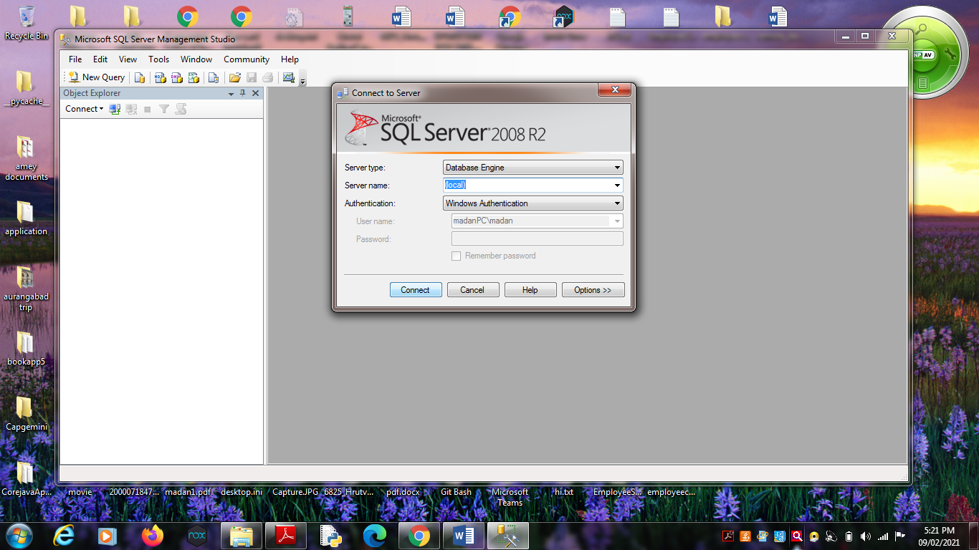

2. Right Click the Database -> New Database

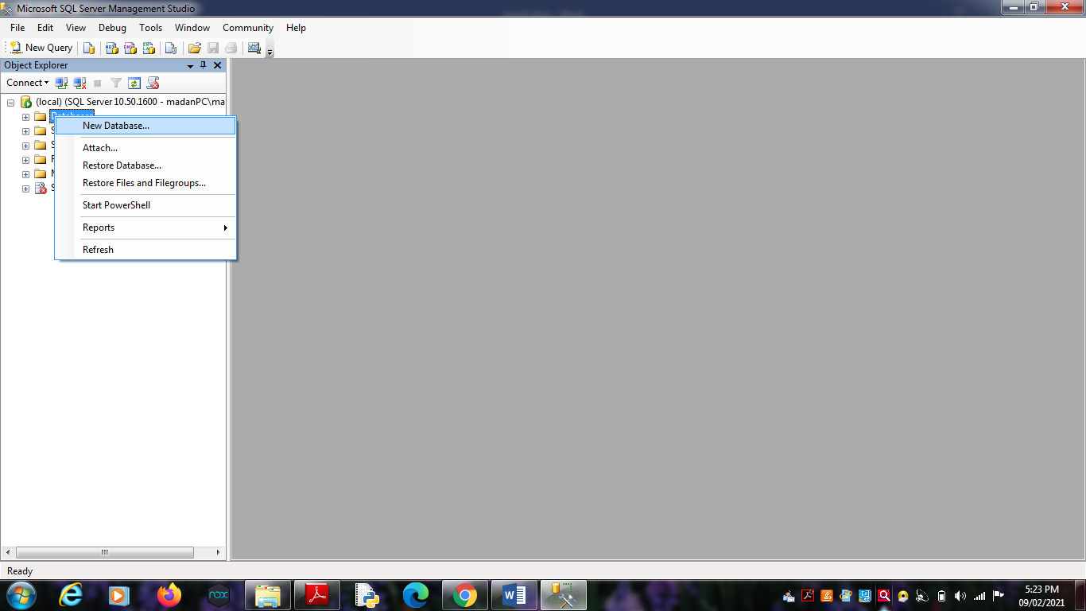

3. Types “SalesProduct” as the database name, click on OK to close the

dialog box and to create the database.

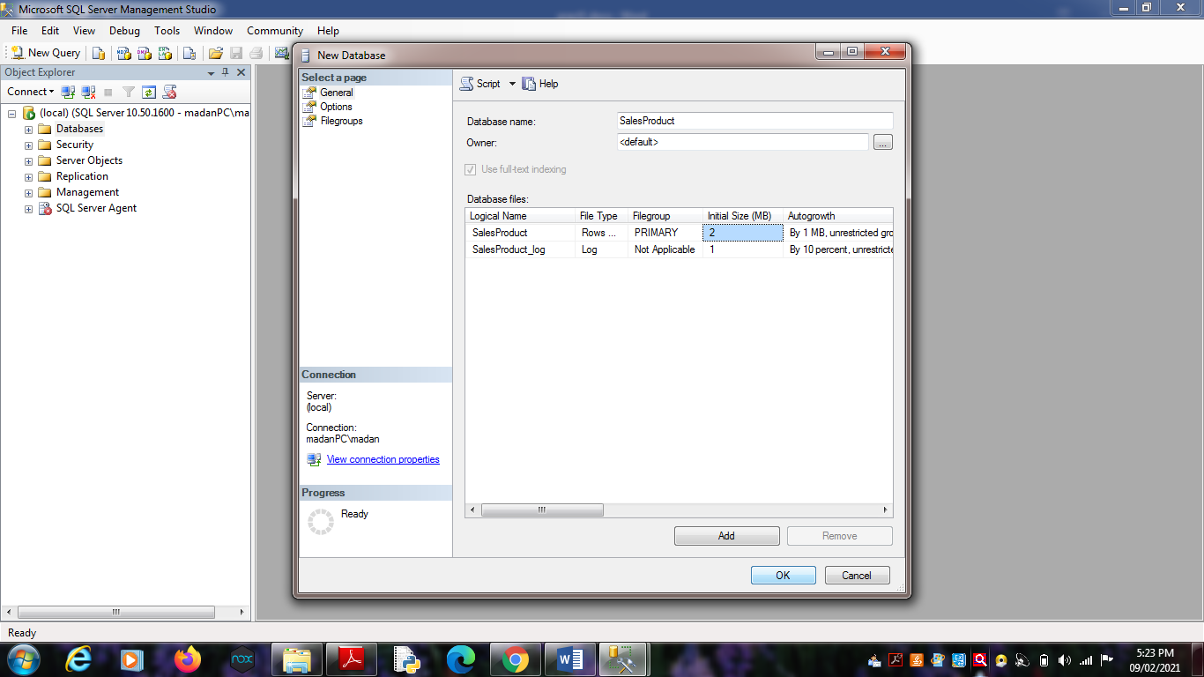

**Create a Database Diagrams**

Expand the “SalesProduct” database folder.

1. Click on Database Diagrams to expand it

On click of it, above Dialog box appears, click on Yes to close it.

2. Right Click on Database Diagrams -> New Database Diagrams

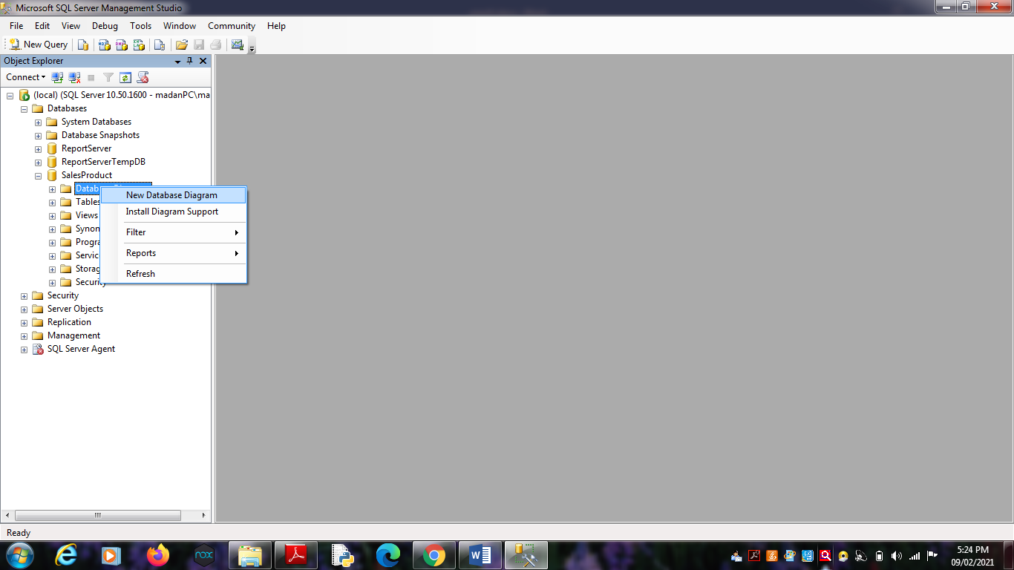 3. Create fact and Dimension Tables. (Right click on surface, choose

New Table to add tables on Database Diagrams.)

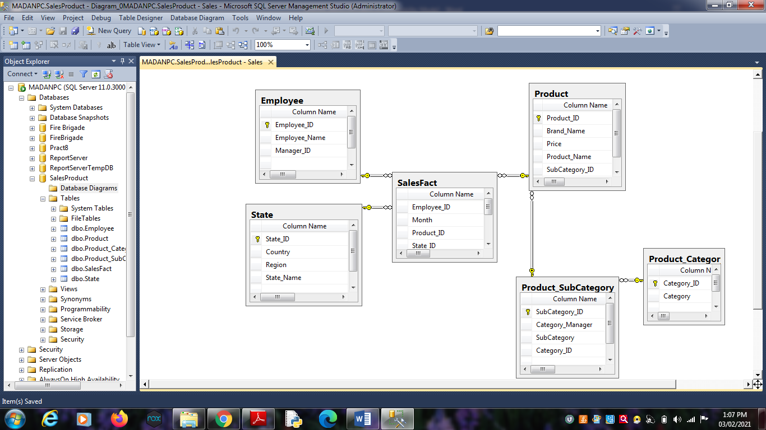

4. Establish relationship between fact and dimension tables.

5. Save Database Diagrams with name as “Sales”. (After saving

Database Diagrams fact and dimension tables are automatically

placed in Table tab.)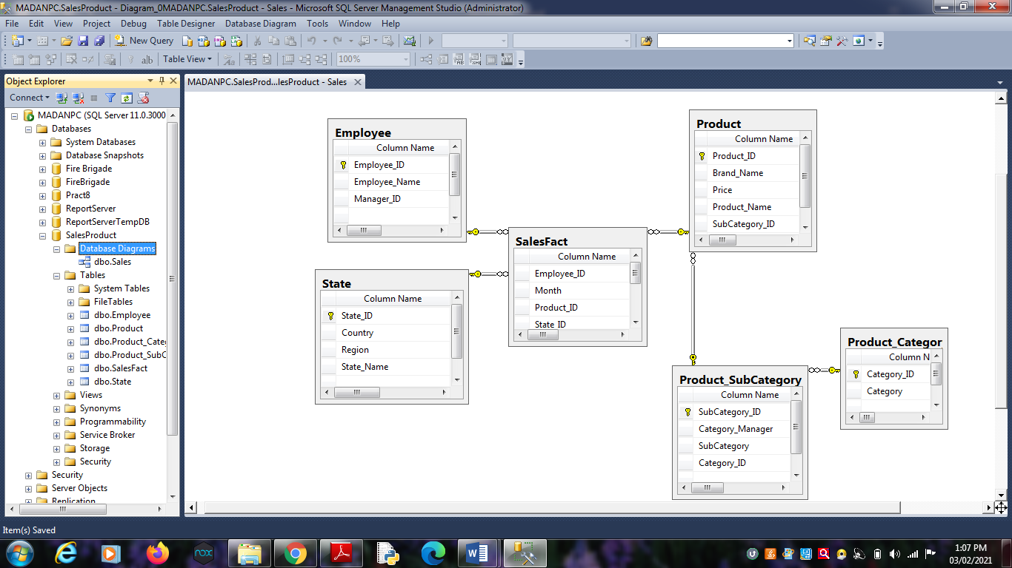

**Practical No 2**

**Aim:** Create Data Source using SSAS(SQL Server Analysis Services.)

**Solution:**

Open Application -> Microsoft SQL Server 2008 R2 -> SQL Server

Business Intelligence Development Studio

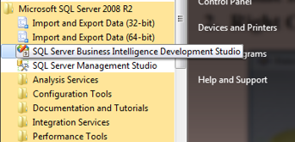

1. Select File -> New Project -> Choose Analysis Service Project ->

Name it as “SalesProduct_BIPrj” and click on OK.

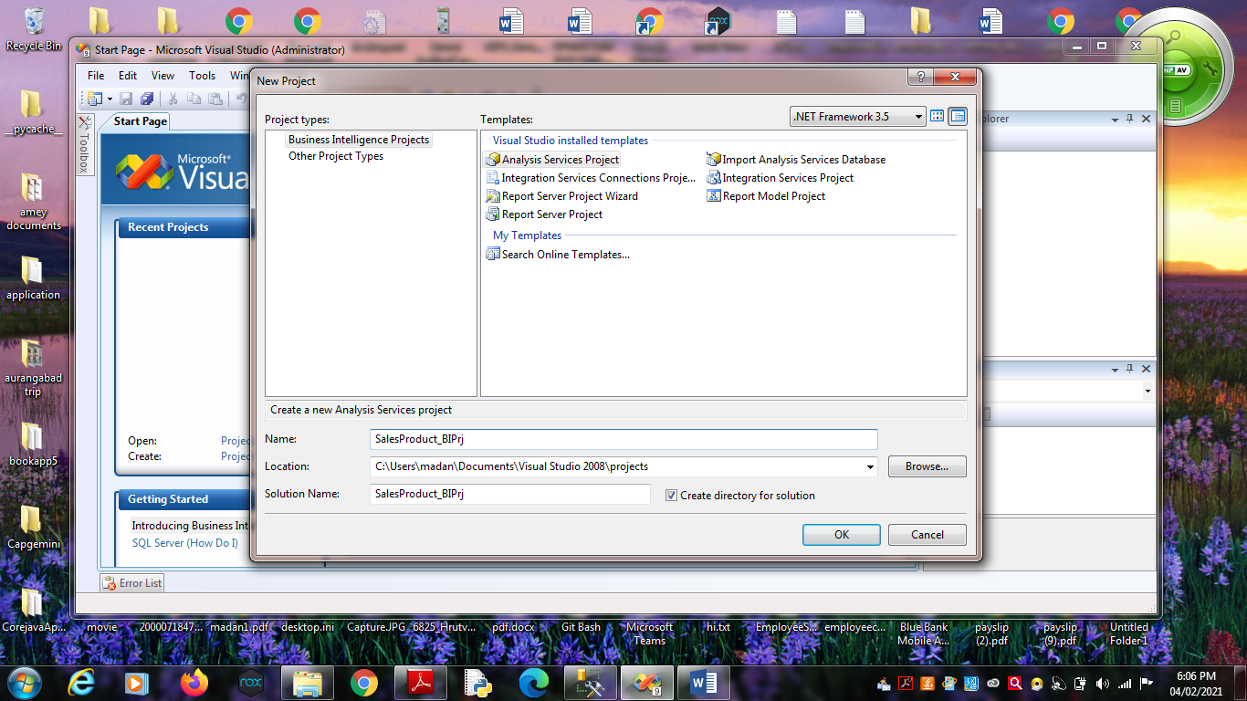

2. Right Click on Data Sources -> New Data Source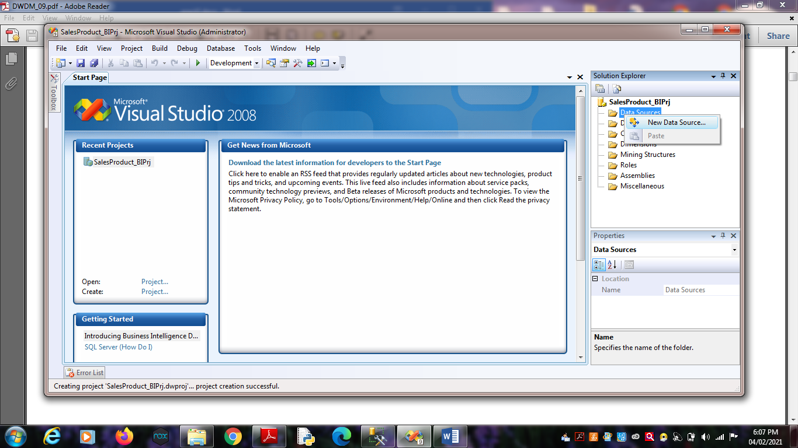

Click on Next.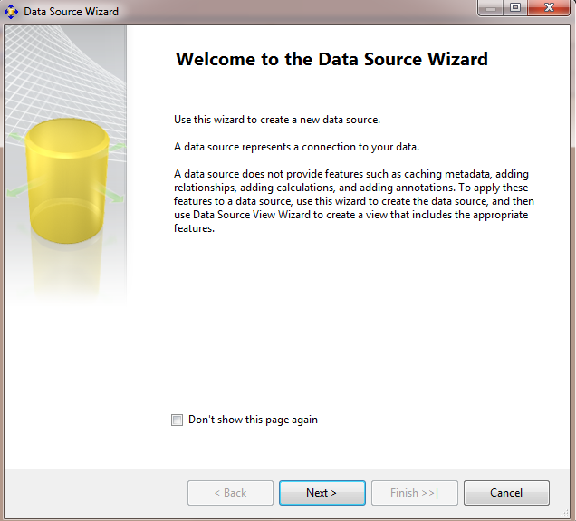

3. Choose Provider as “Microsoft OLEDB Provider for SQL Server” ,

Server Name as “.”, Select database name as

“SalesProduct”.(Created in SQL Server Management studio).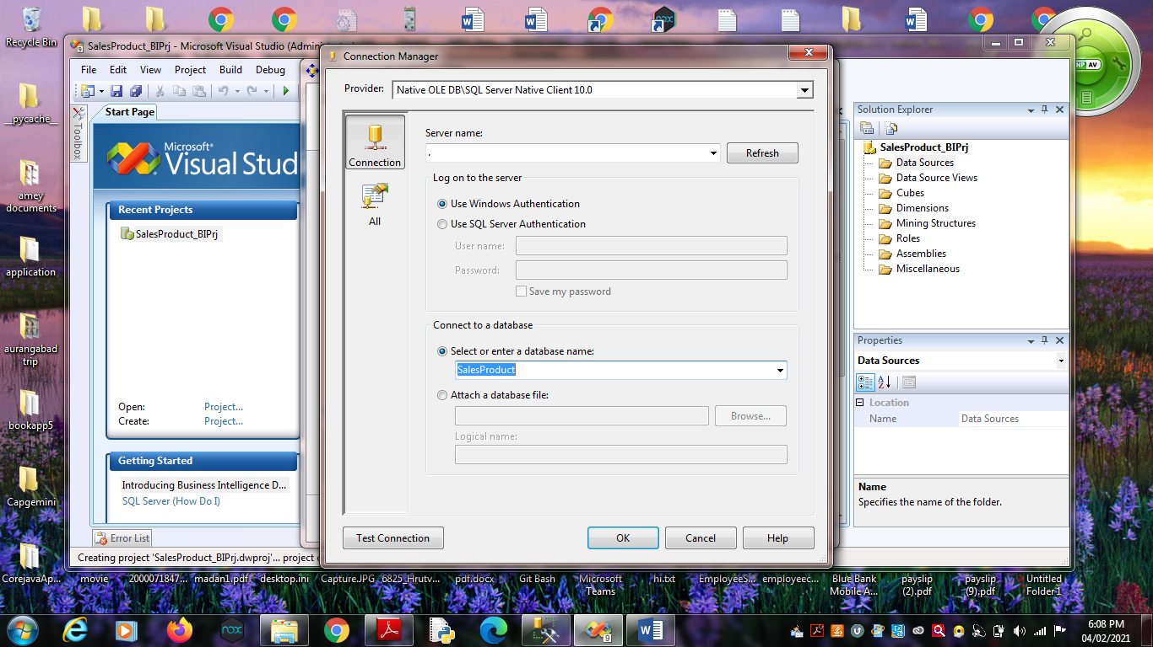

Click on Next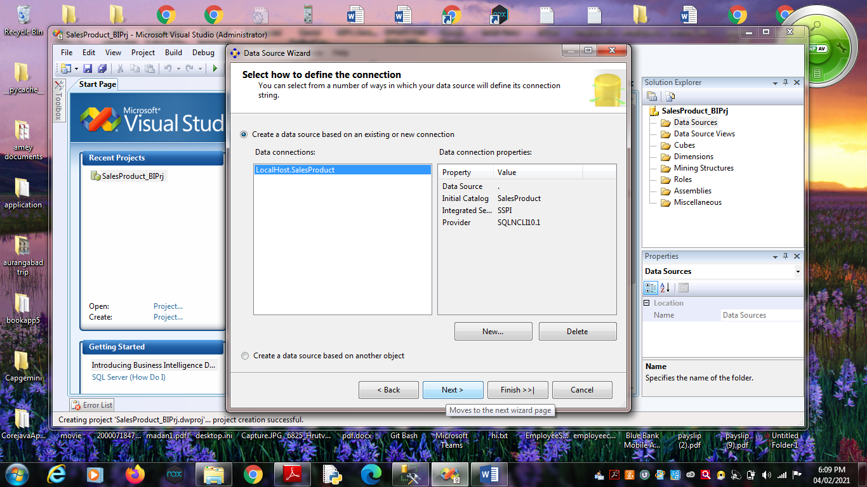5. Choose “Inherit” option.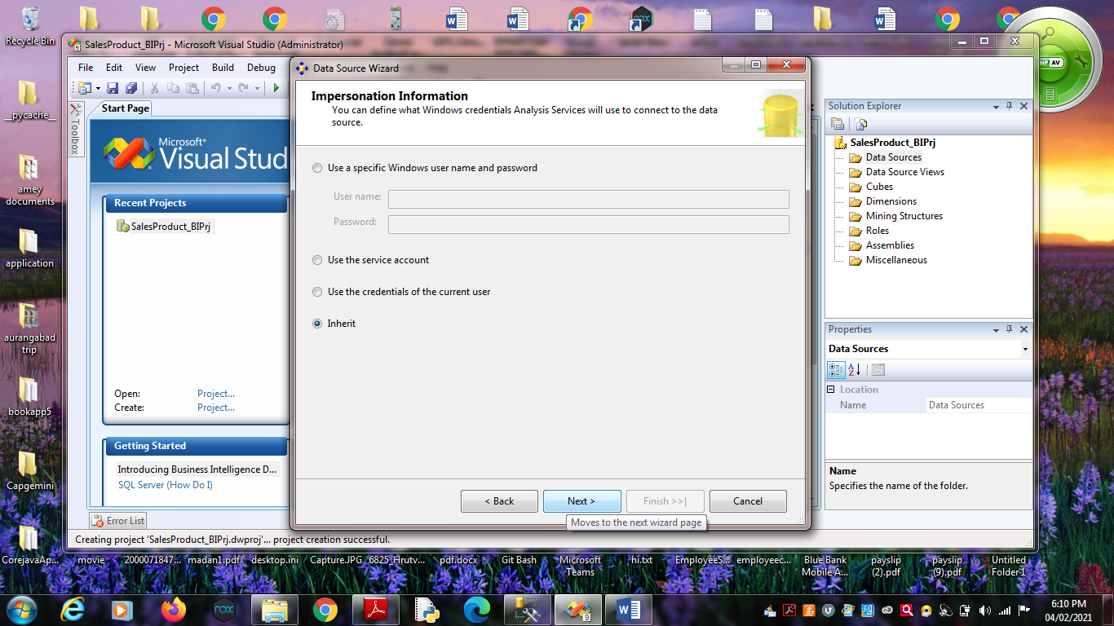 Click on Next.

6. Click on Finish.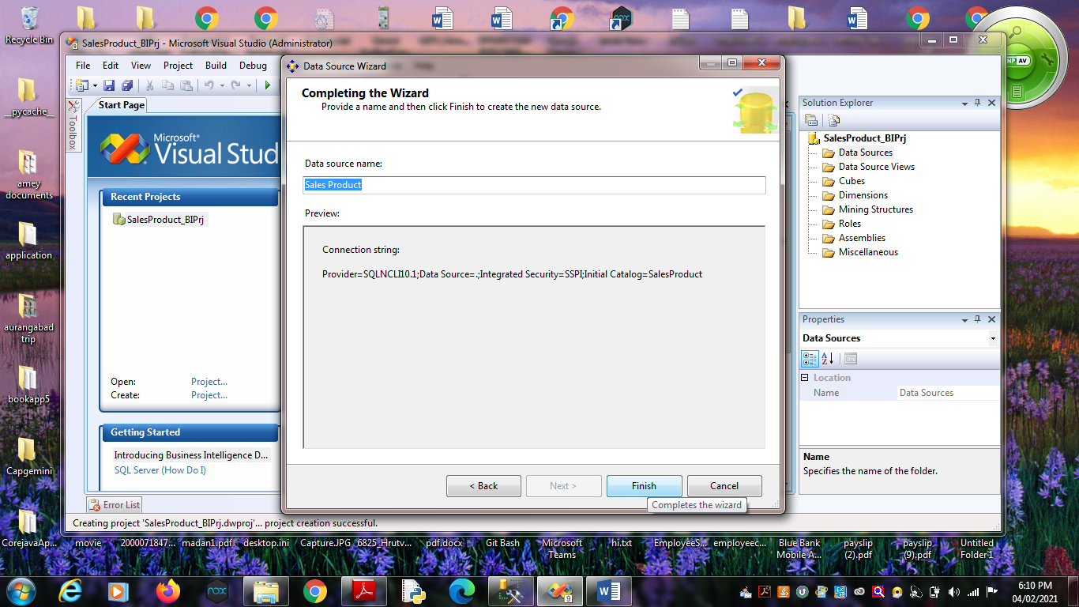

Name Data Source as “Sales Product”.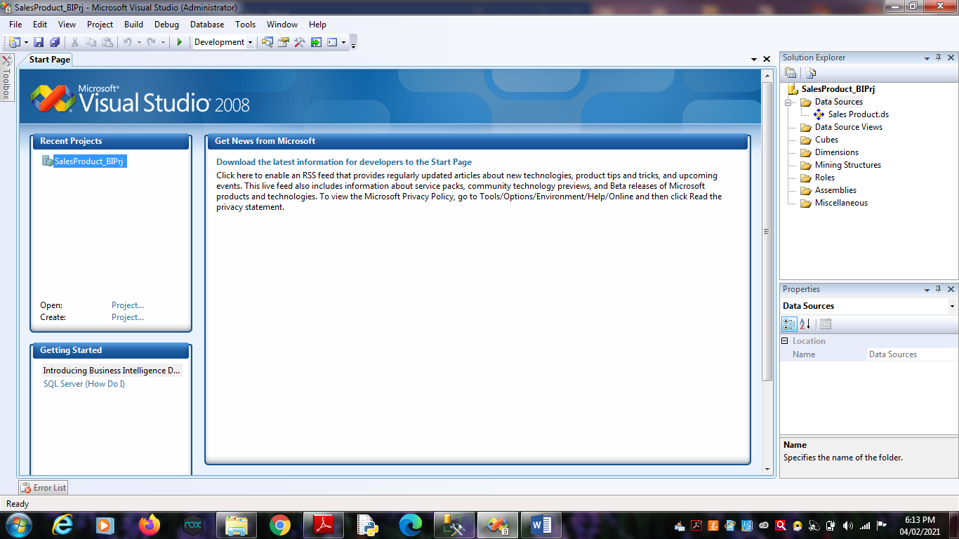

**Practical No 3**

**Aim:** Create Data Source View using SSAS(SQL Server Analysis

Services.)

**Solution:**

1. Right click on Data Source View -> New Data Source View

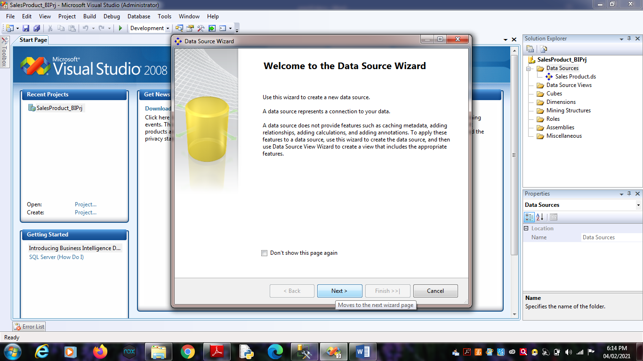Click on Next.

2. Click on Next.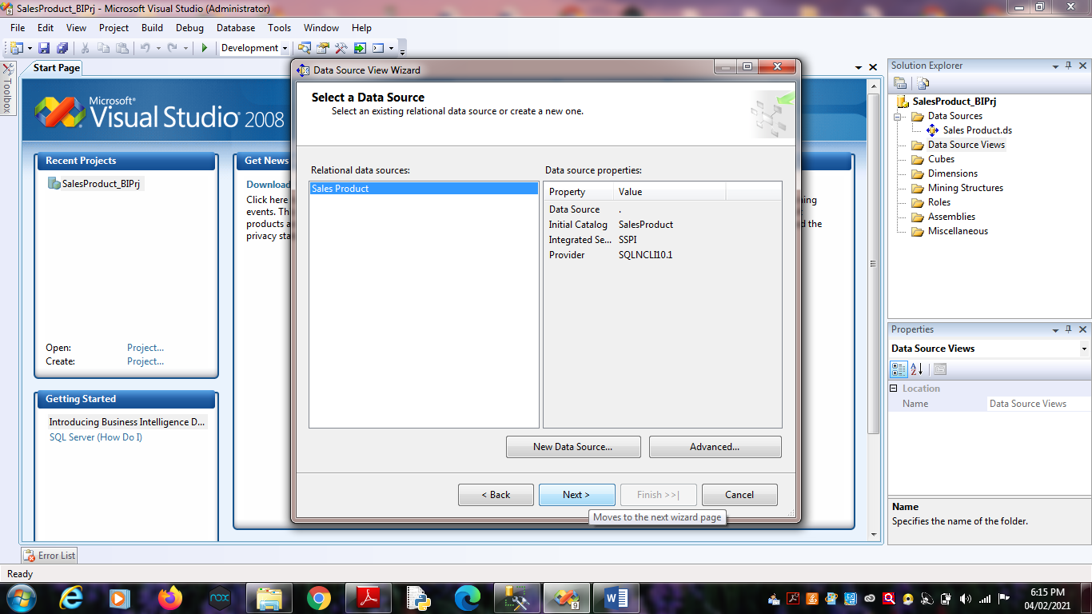

3. Select Tables and Views.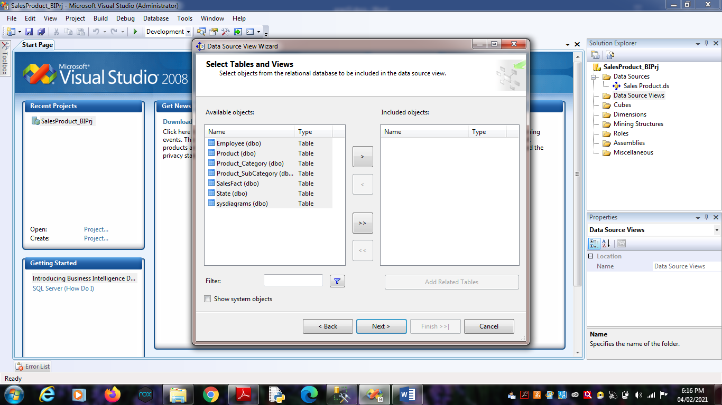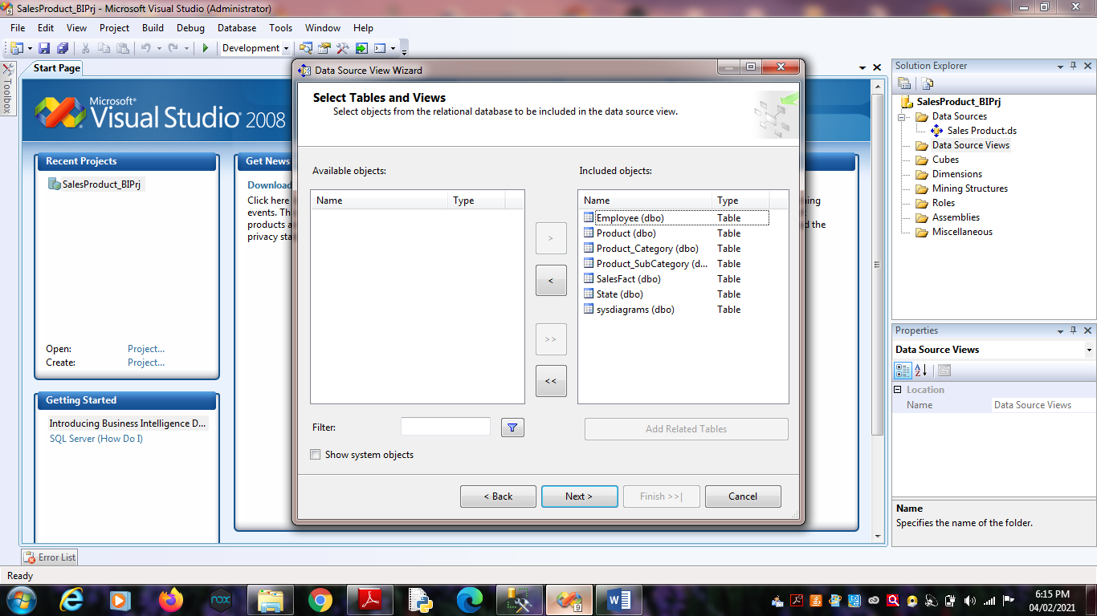 Click on Finish.

4. Finally, we will get the Data Source View like :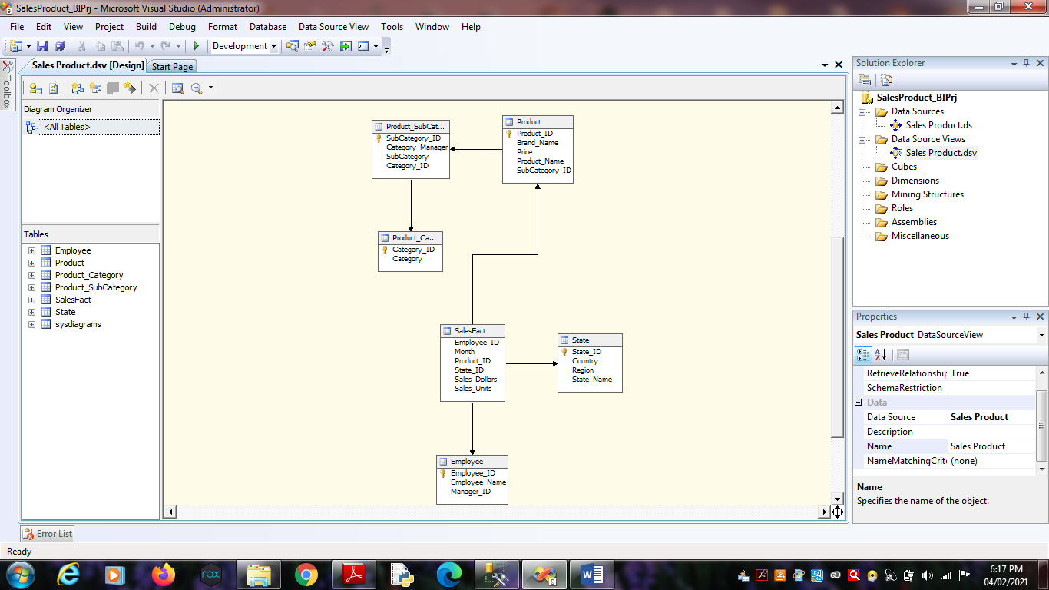

**Practical No 4**

**Aim**: Create cube using SSAS(SQL Server Analysis Services.) and process

the cube.

**Solution:**

1. Right click on Cubes -> New Cube.

Click on

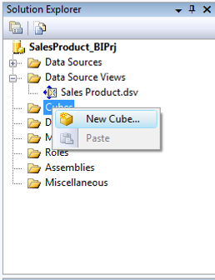

Click on Next.

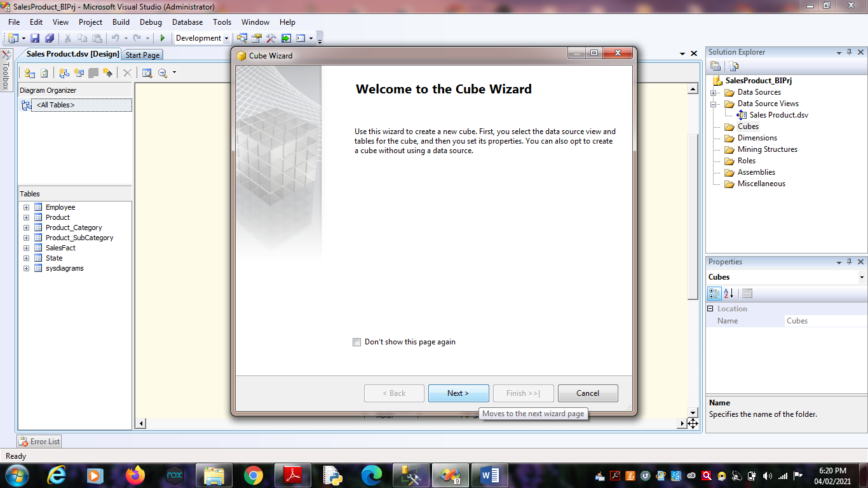

2. Select First option “Use existing tables”. Click on Next.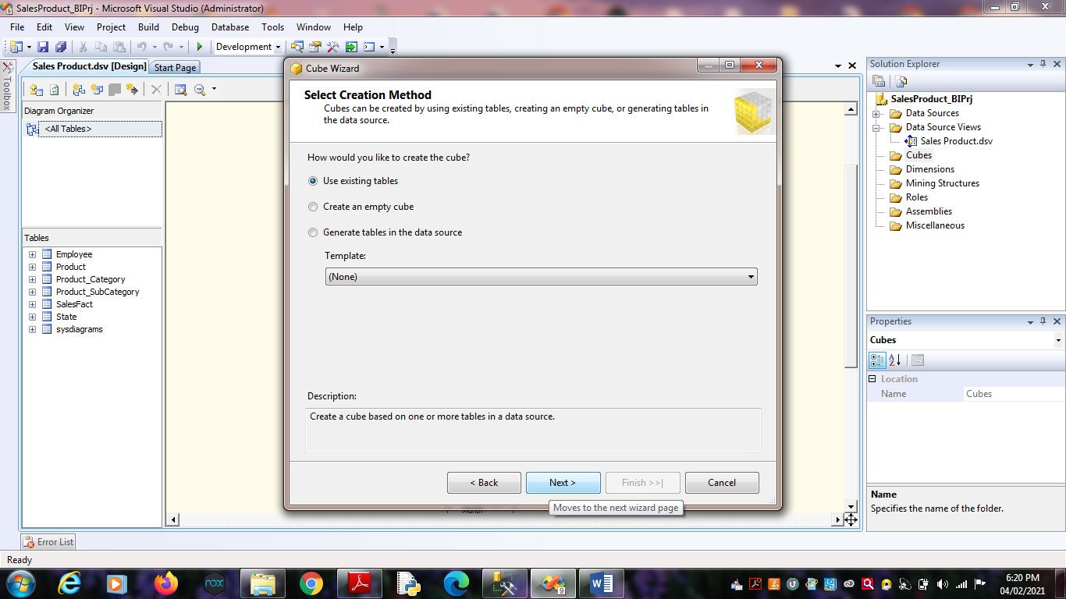

3. Select Data Source View as “Sales Product” and Select all the tables.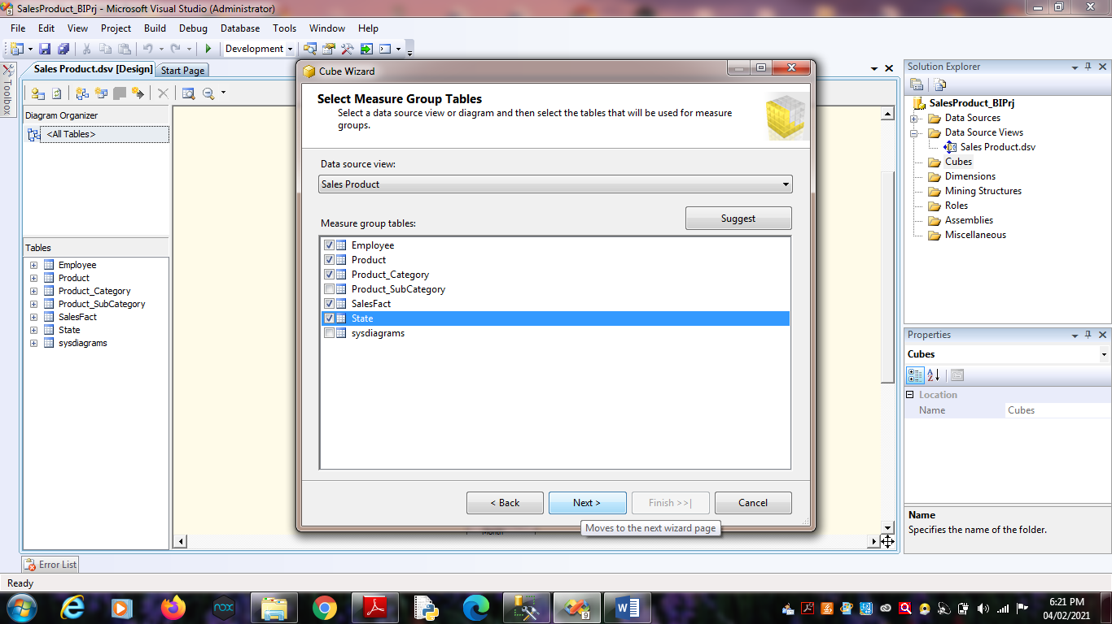

Click on Next.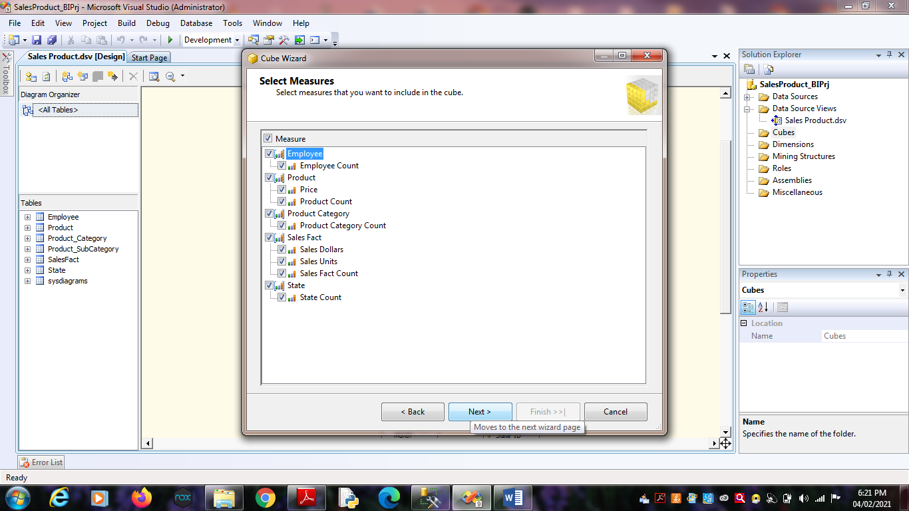 Click on Next.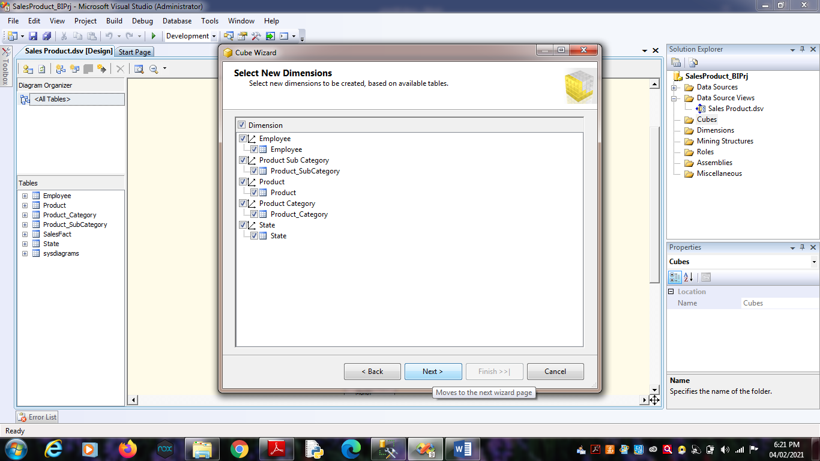 Click on Next.

4. Name Cube as “SalesCube”.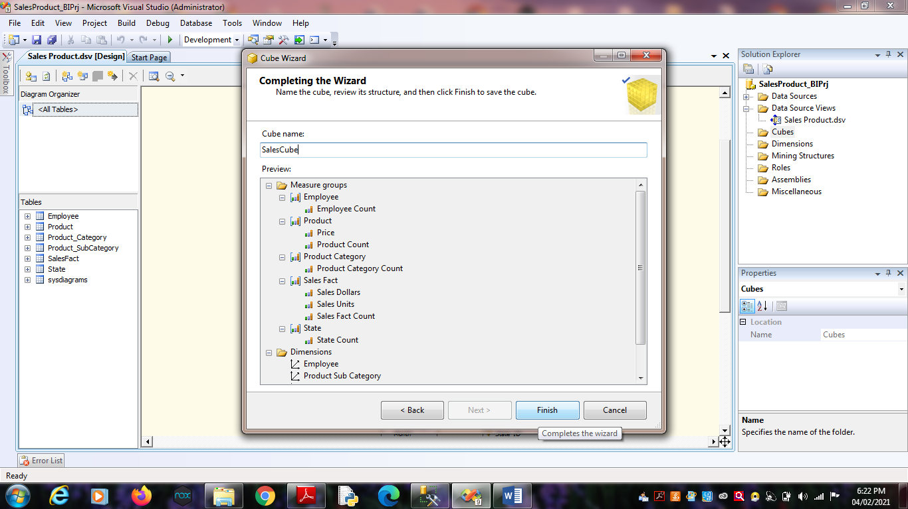

Click on Finish.

5. Finally, we will get the Cube View as well Dimensions View like :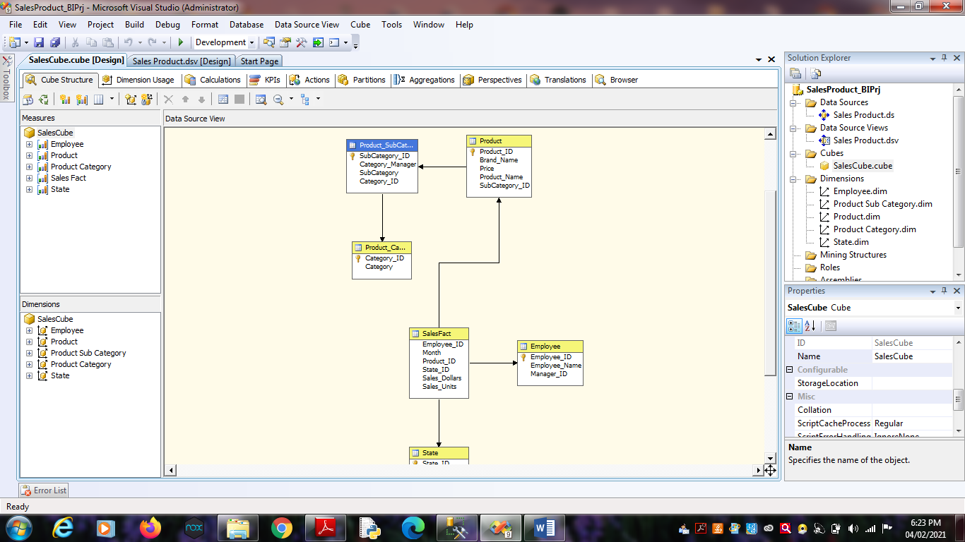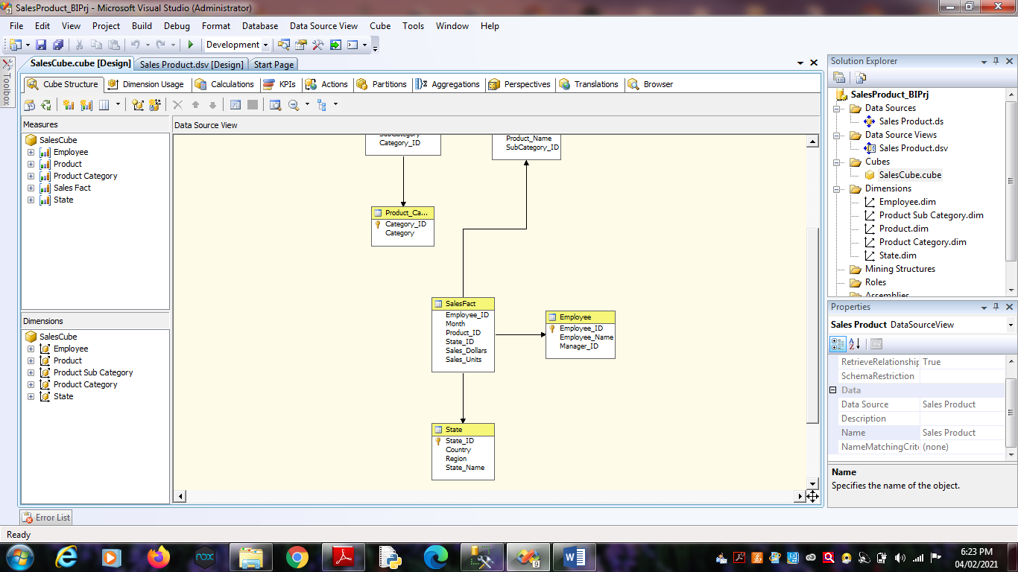

6. Finally, Process cube by Right click on SalesCube -> Process .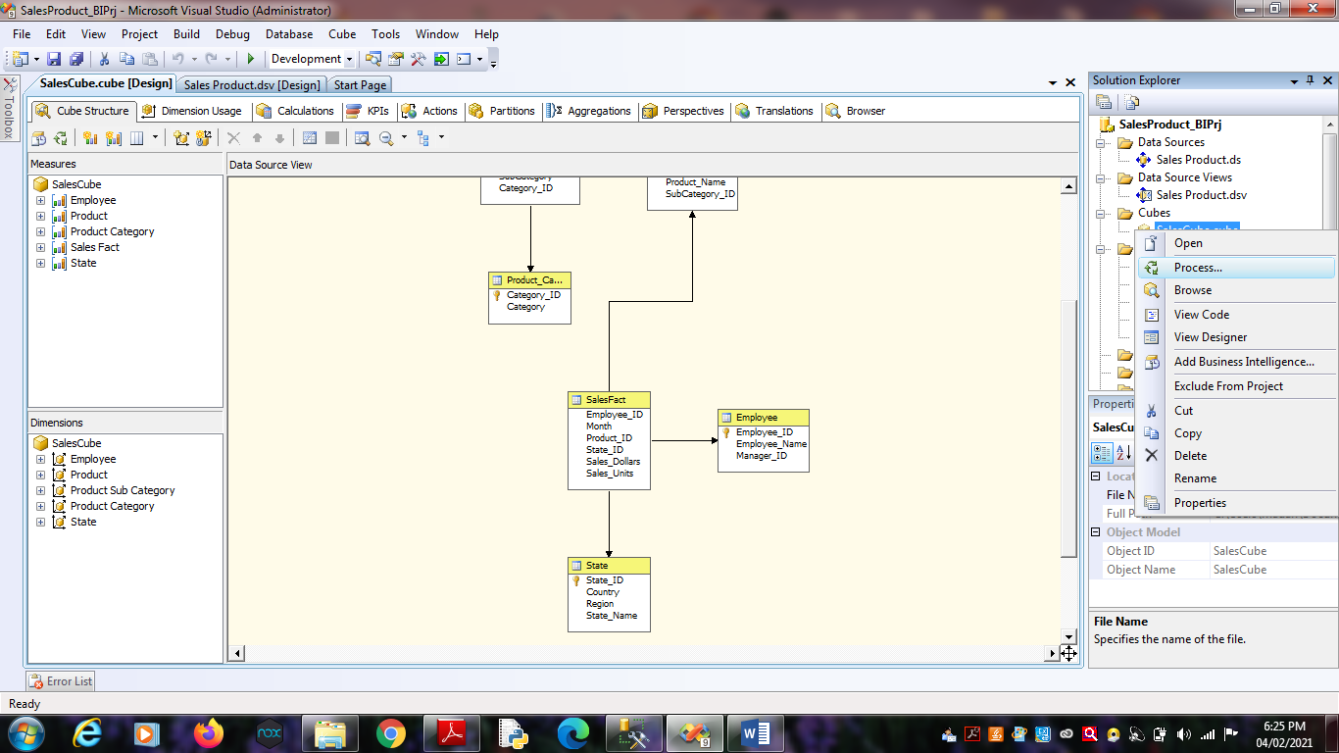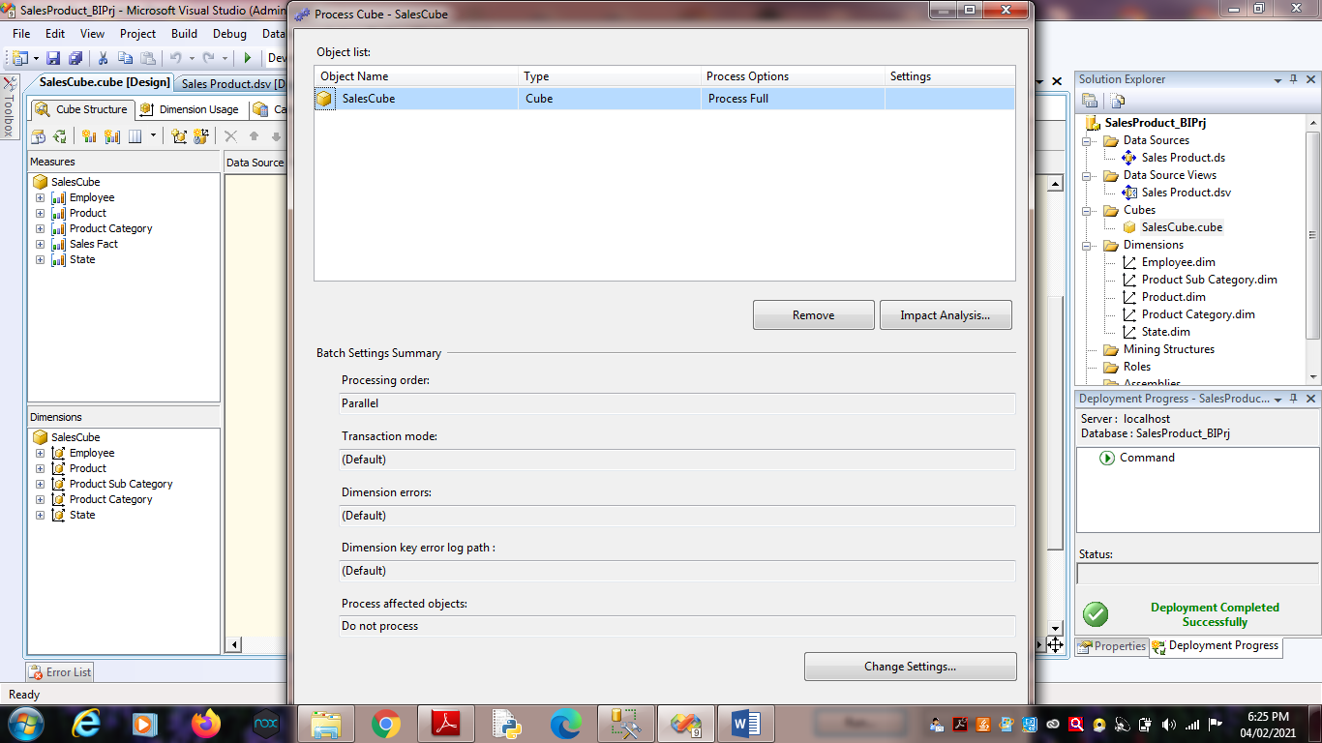

7. Click on Run.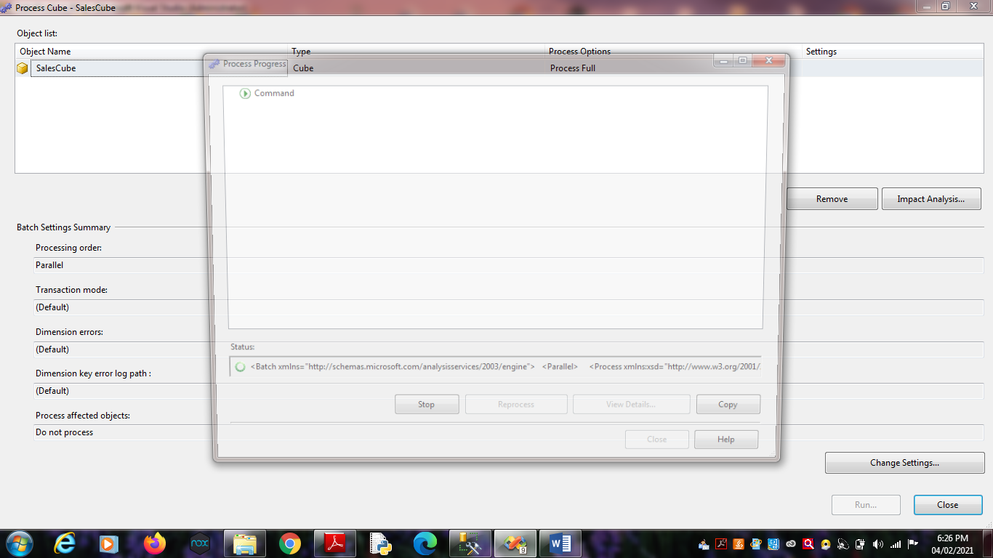

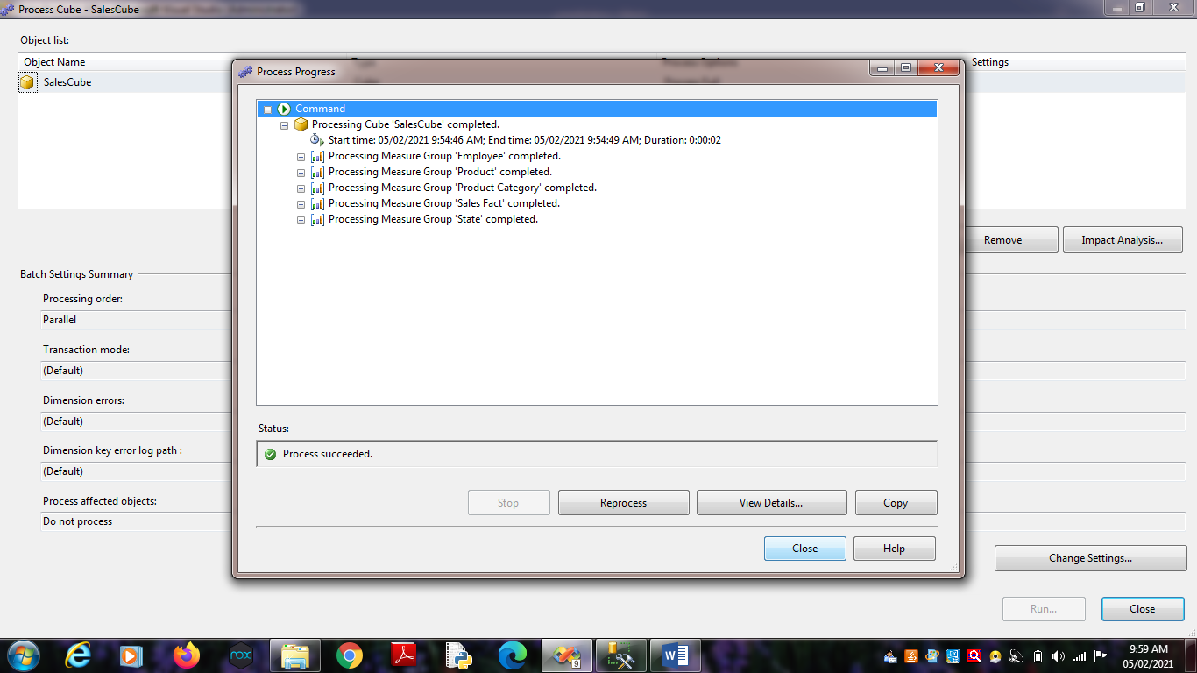

**Practical No 5**

**Aim:** View cube data in multidimensional Format.

**Solution:**

1. Double Click on “SalesCube”. Go to the “Browser” Tab.

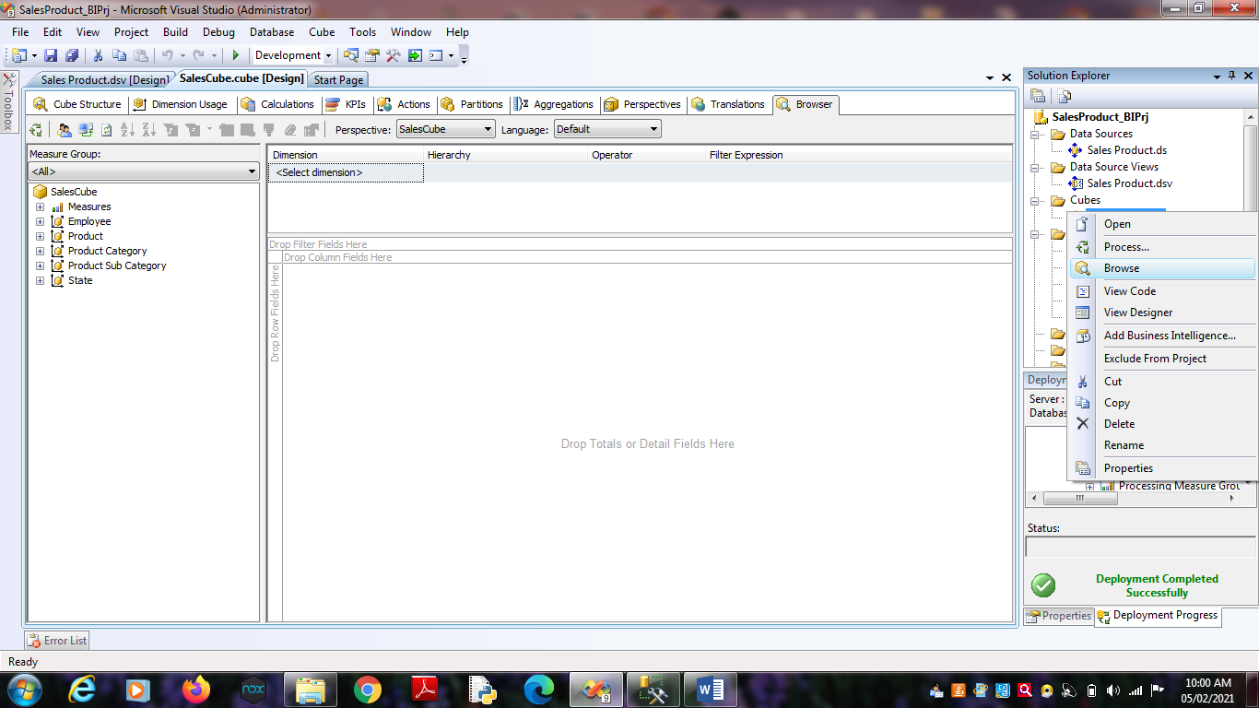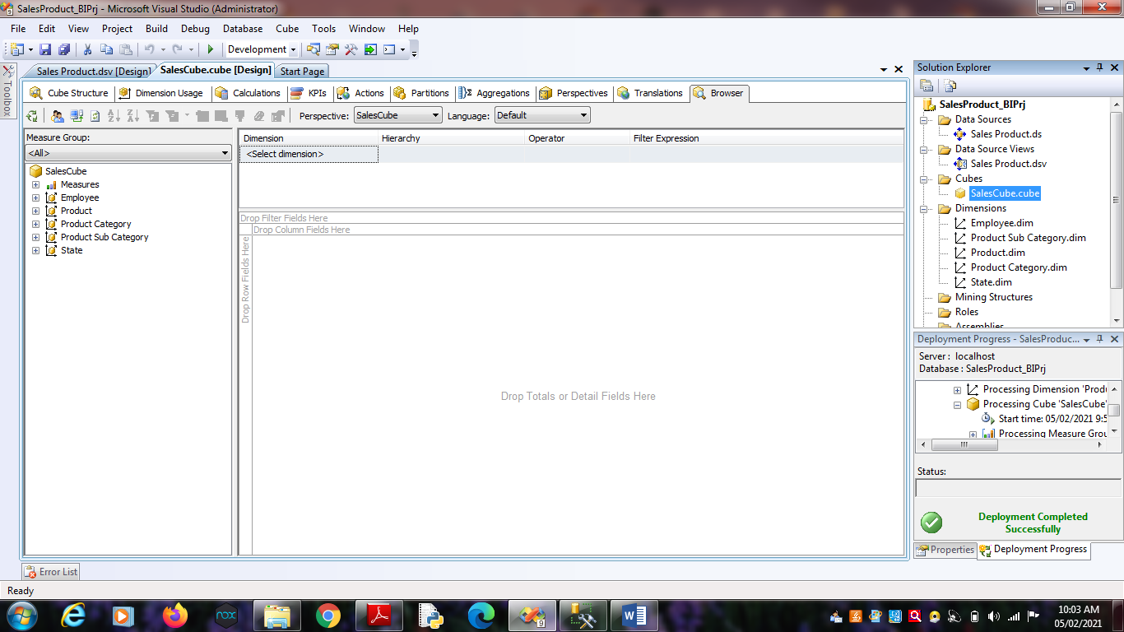2. Go to the “State Dimension”. Right Click on ‘State_ID’ -> Add to

Row Area.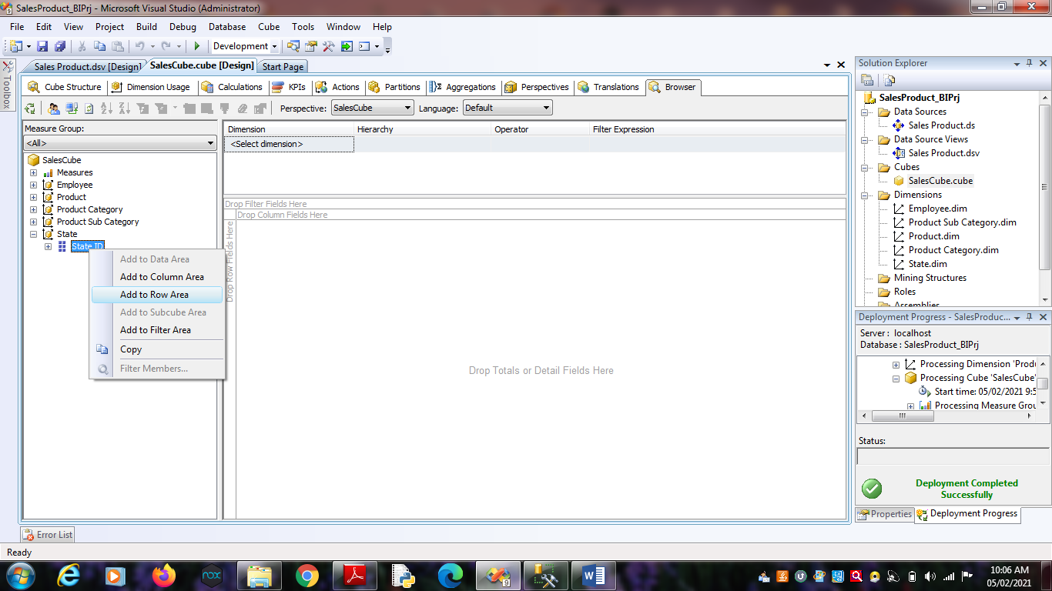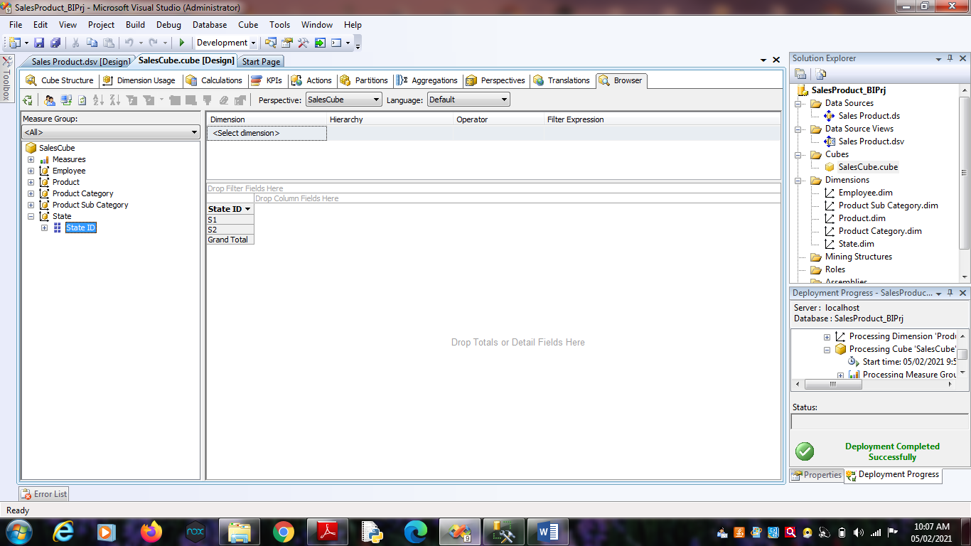 3. Go to the “Product Dimension”. Right Click on ‘Product_ID’ -> Add

to Column Area.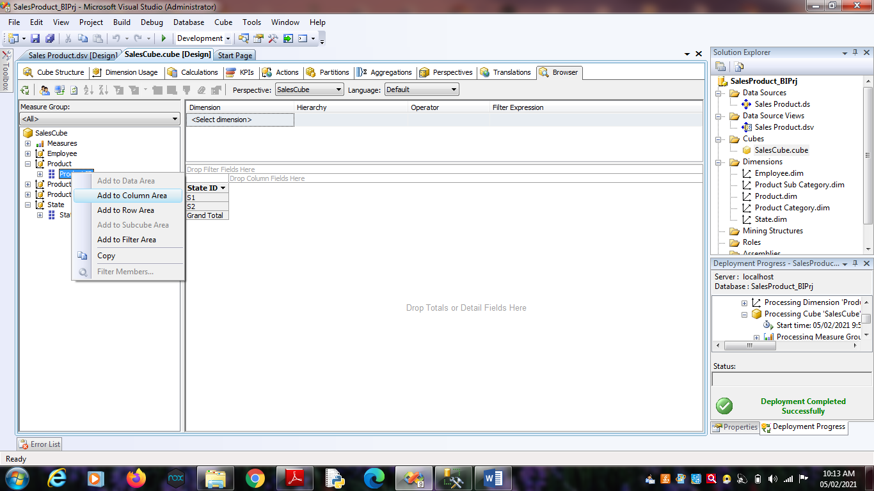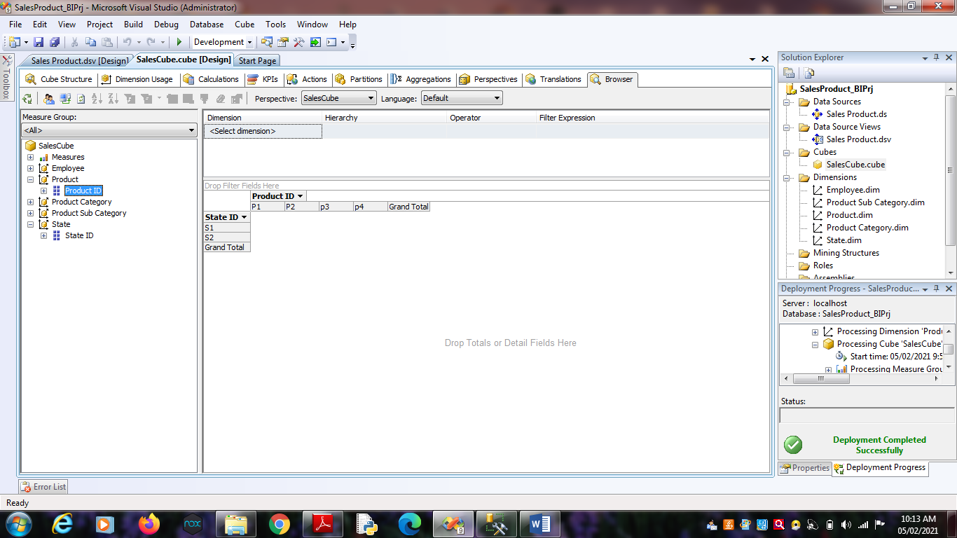 4. Go to ‘Measures’. Select ‘SalesFact’ -> Right Click on “Sales

Dollars” as well “Sales Units” -> Add to Data area.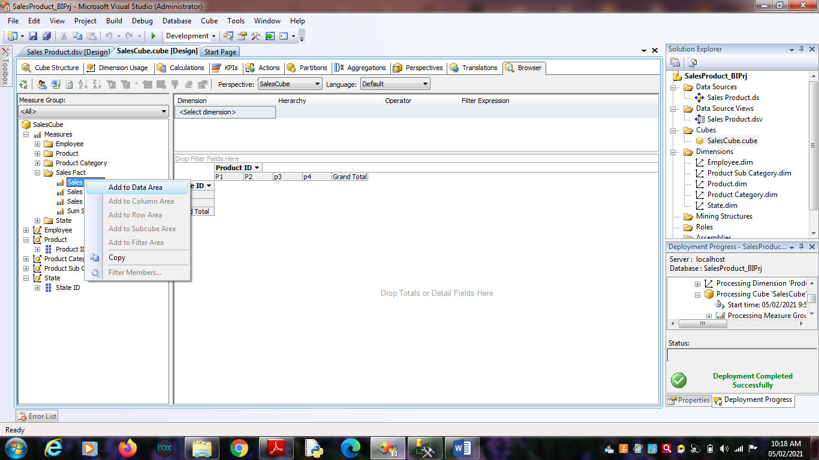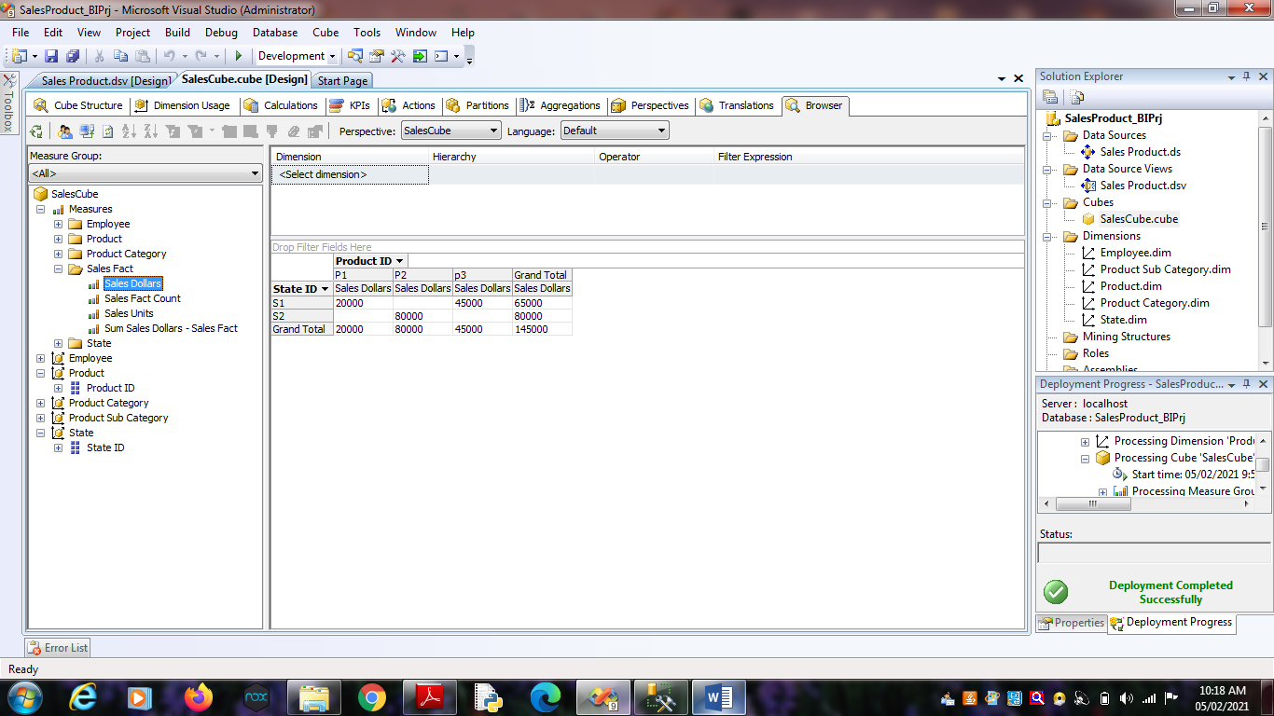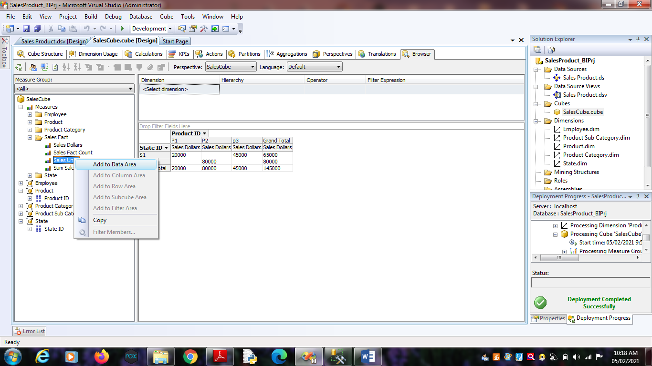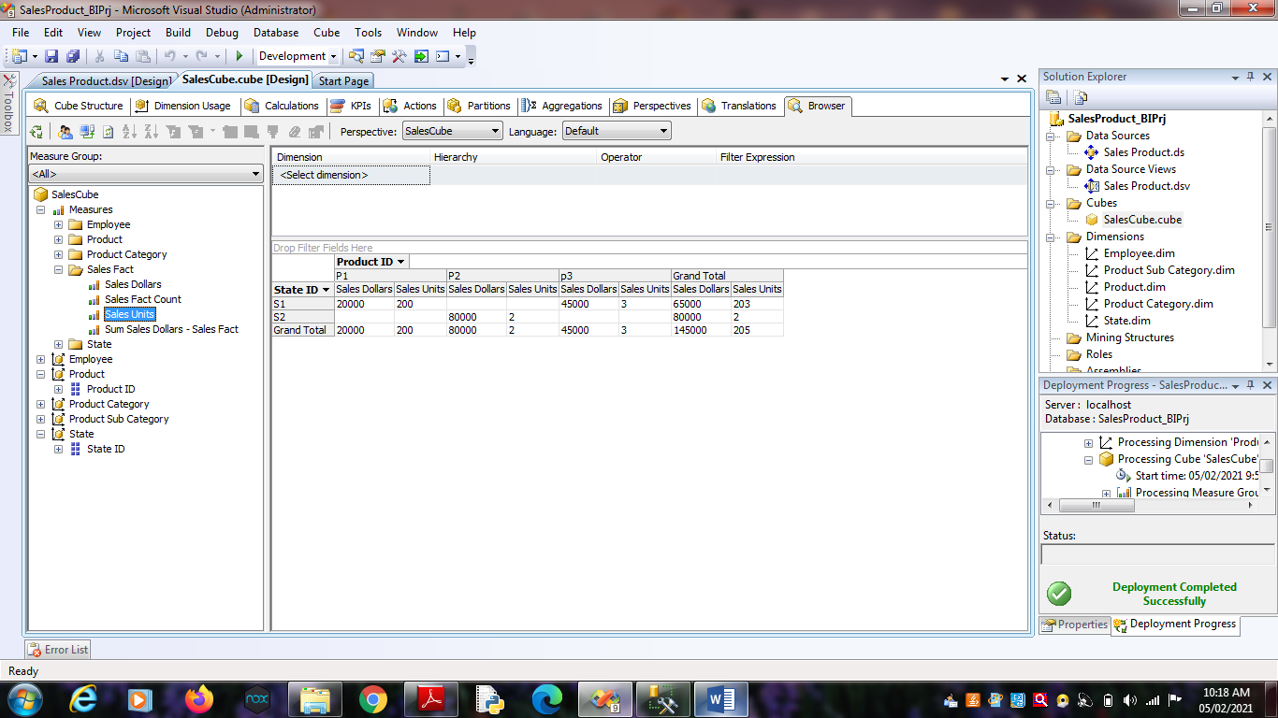 5. Go to the “Employee Dimension”. Right Click on ‘Employee_ID’ ->

Add to Row Area.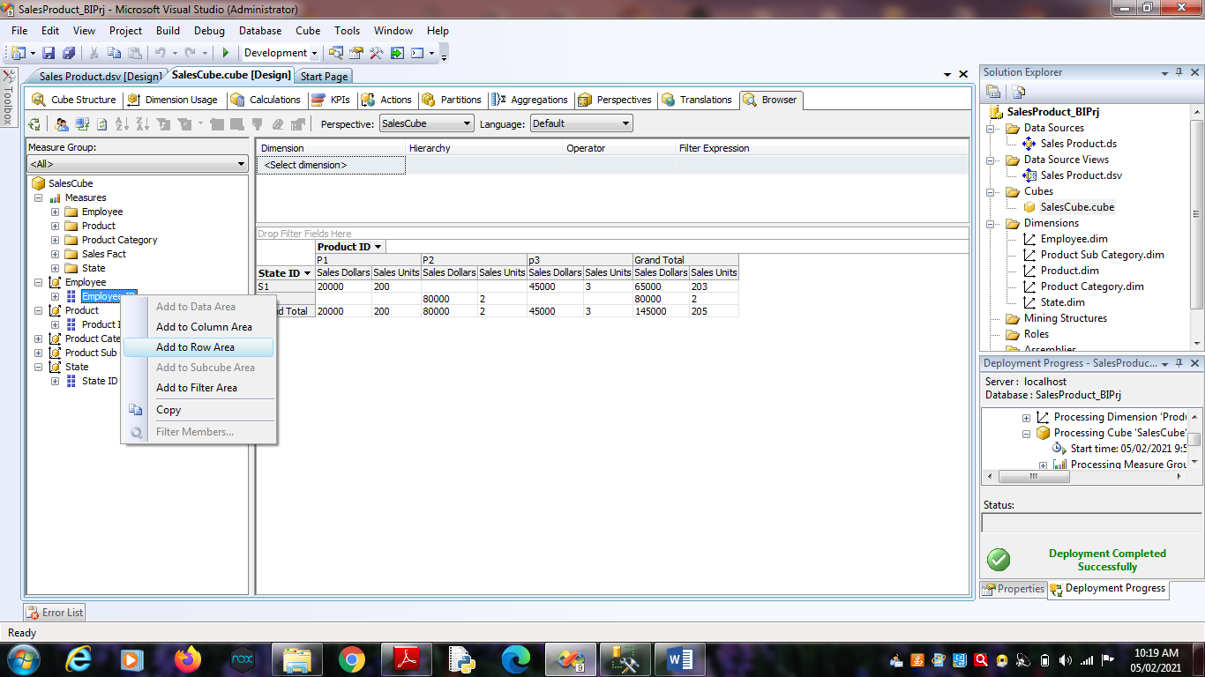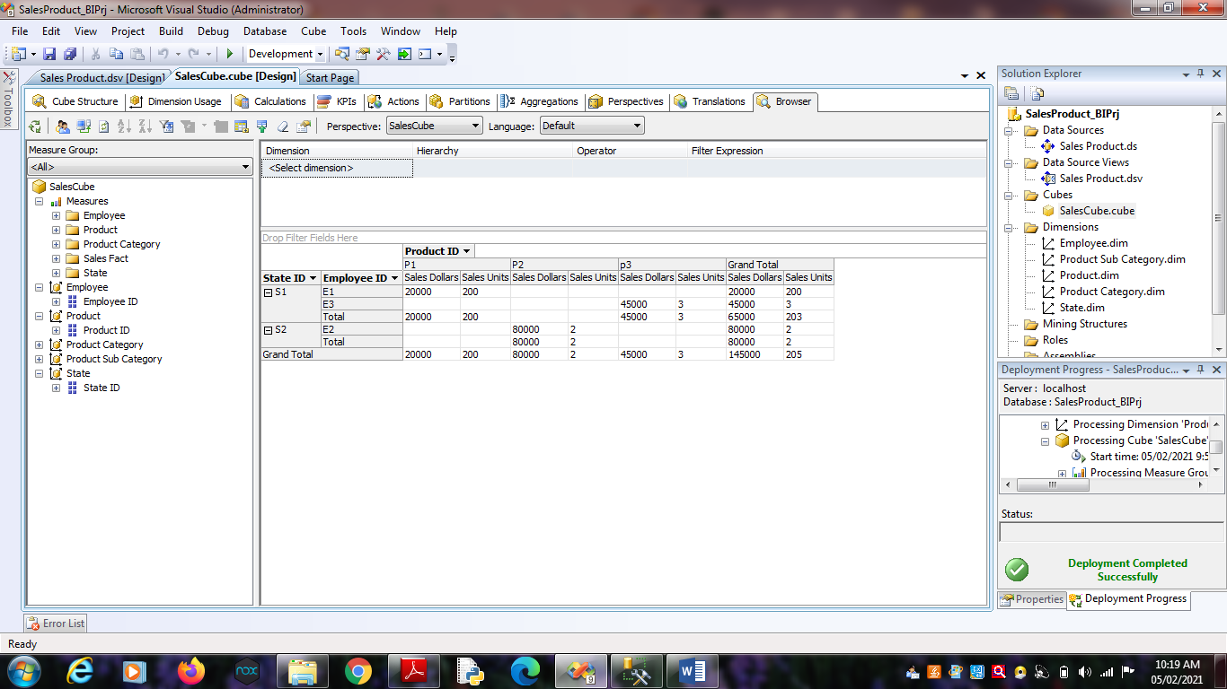

**Practical No 6**

**Aim :** Working with measures in the cube.

**Solution :**

1. Double click on ‘SalesCube’. Go to cube structure.

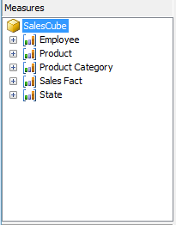

2. Right click on SalesCube -> New Measure.

Select Usage = “Sum” , Source table = “SalesFact” and Source

Column = “Sales_Dollars”.

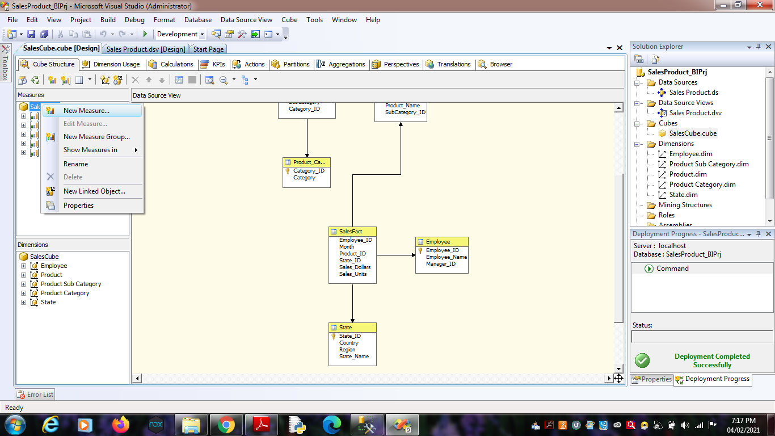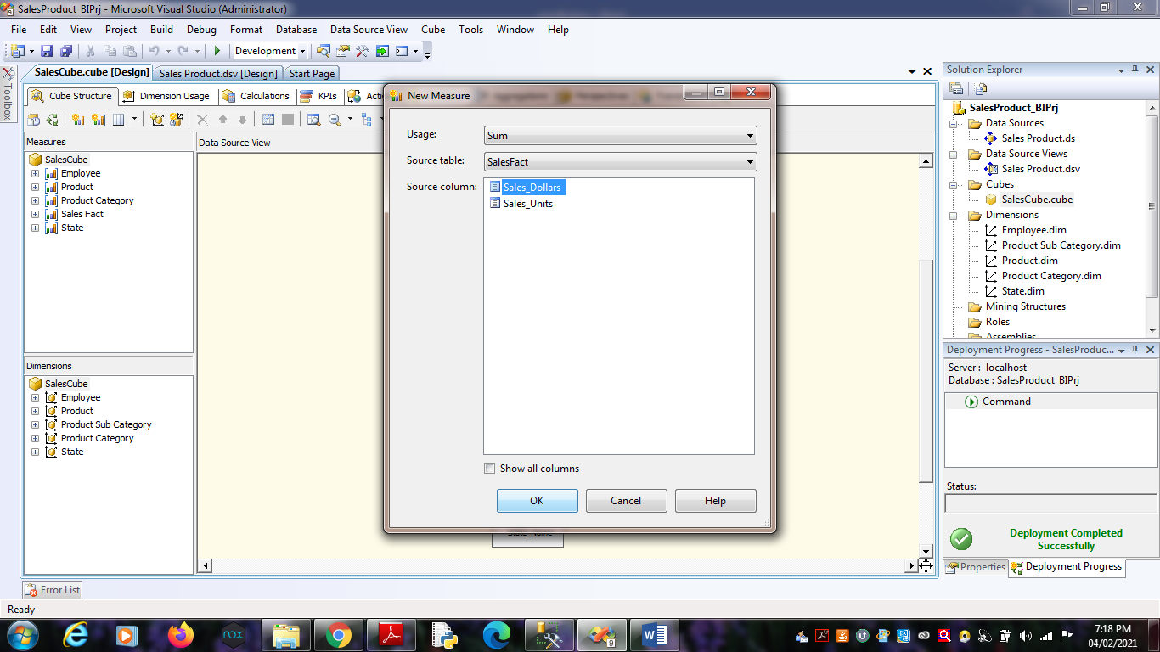Click on OK.

4. Process Cube and Go to Browser and Reconnect it. Right Click on

“Sum Sales Dollars” -> Add to Data Area.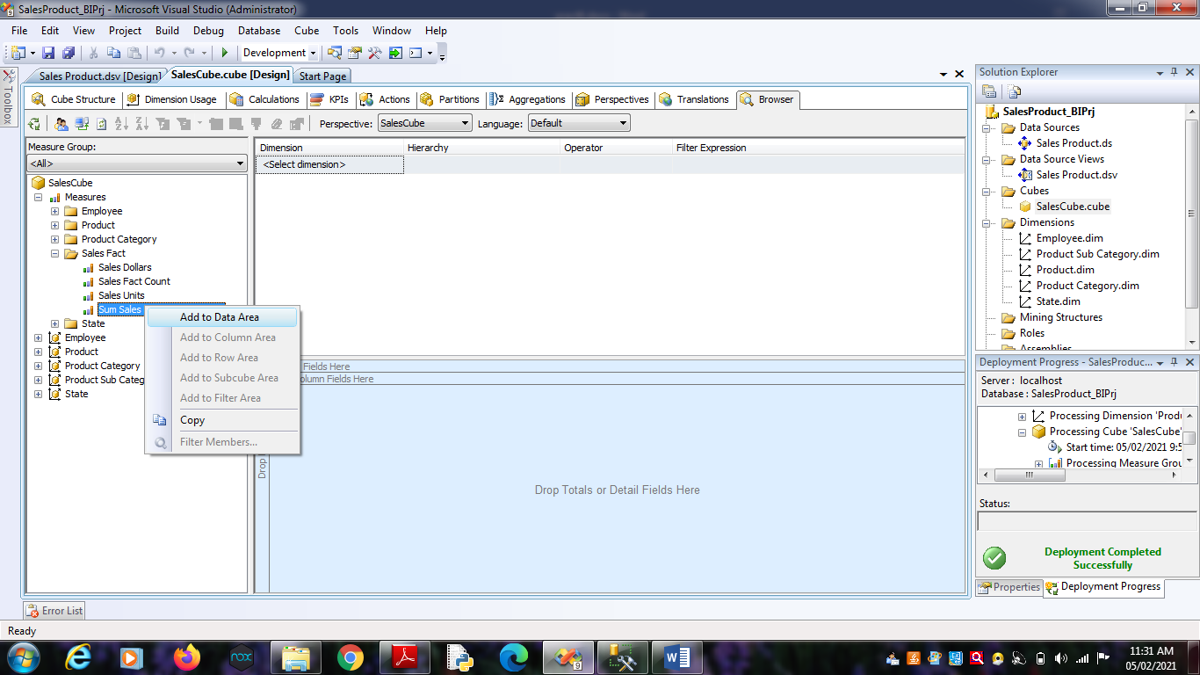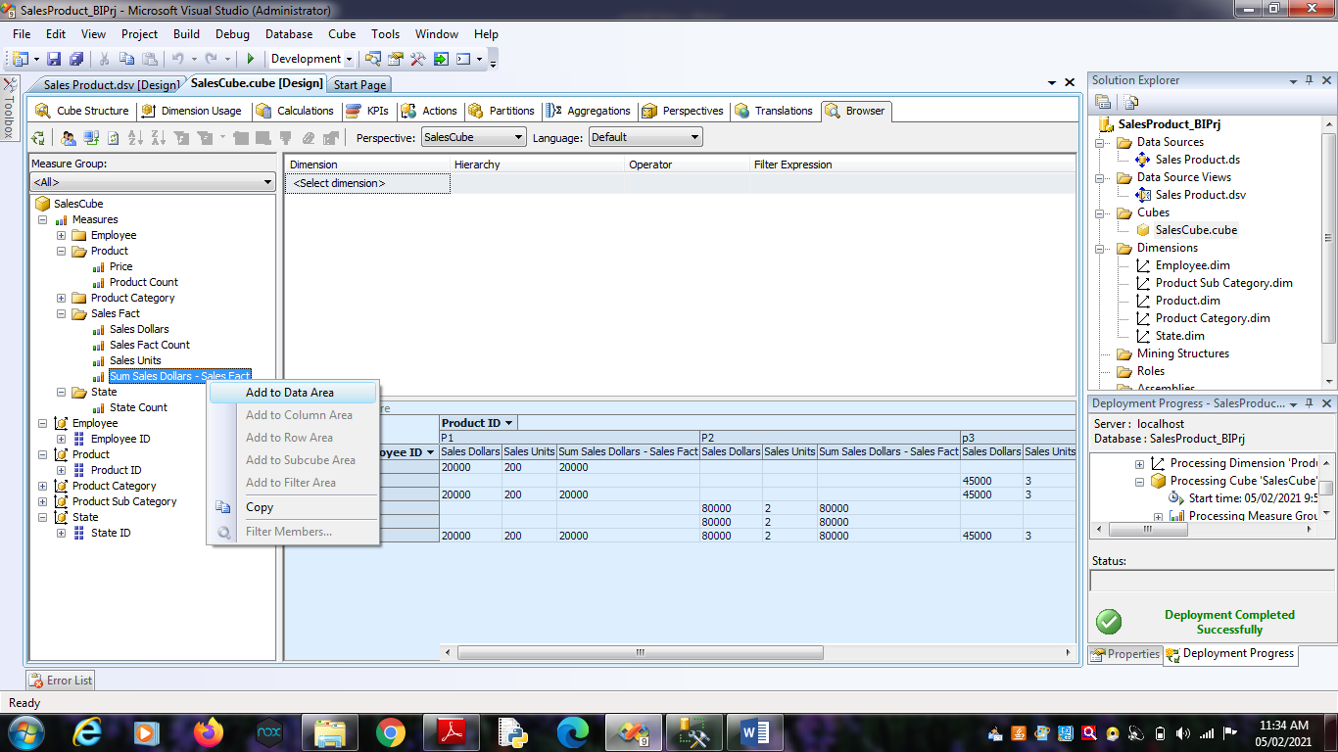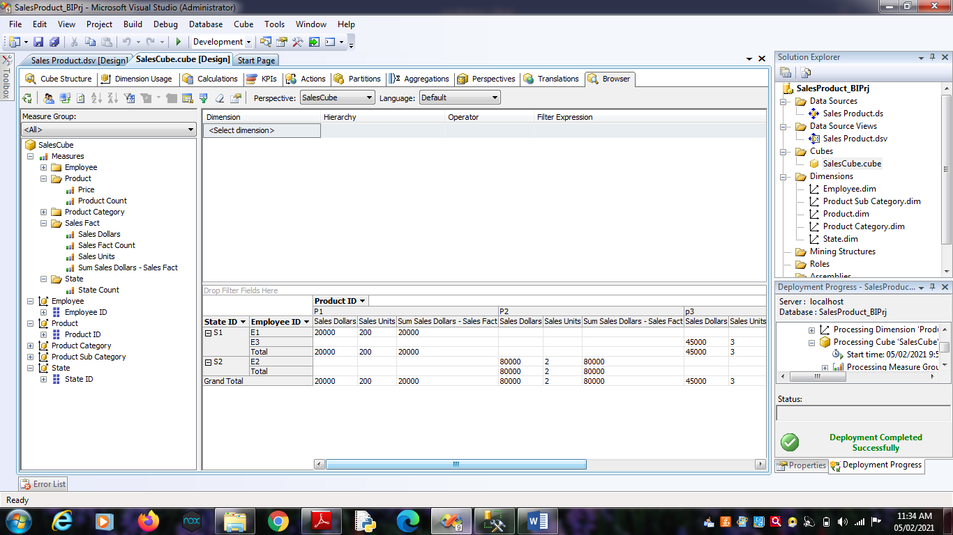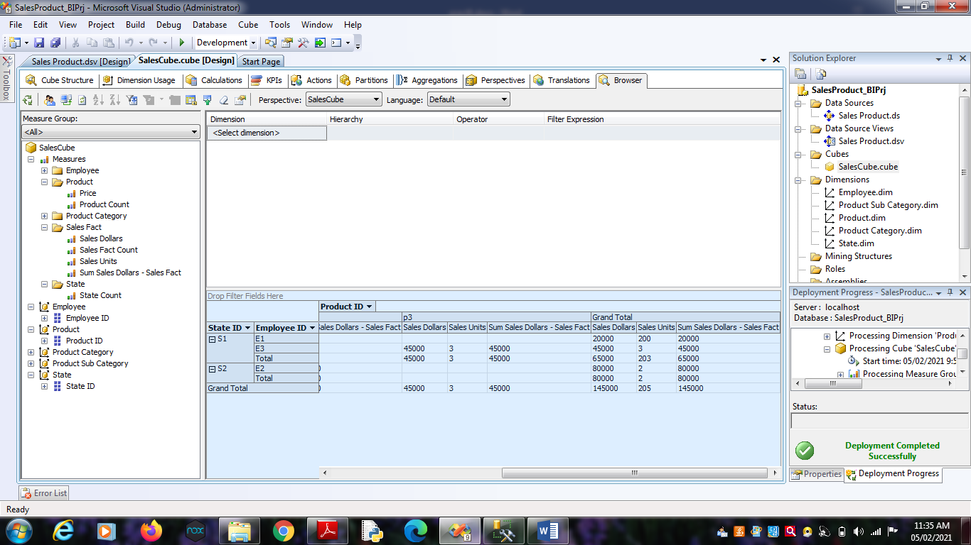

**Practical No 7**

**Aim:** Creating an Excel Pivot Table and Pivot Chart by using the OLAP cube data.

**Solution:**

1. Open MS-Excel. Click on Data Menu.

2. Go to From Other Sources.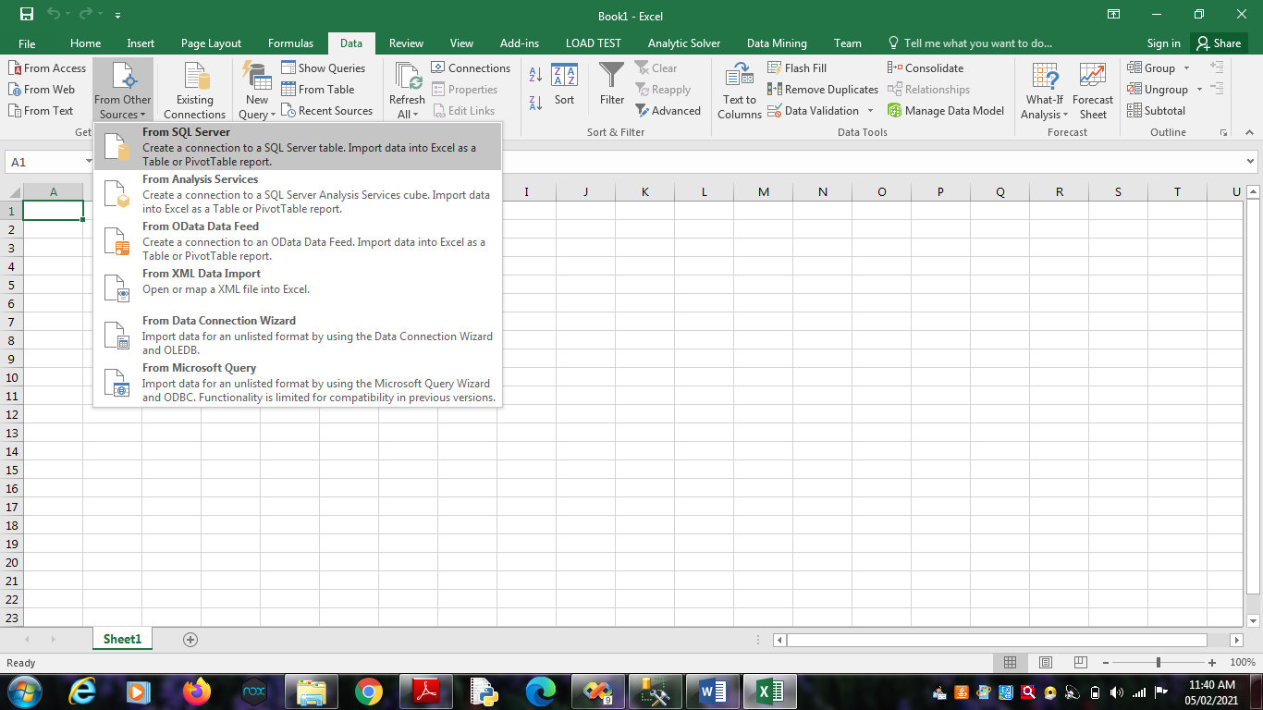

2.1. From SQL Server -> Type Server name as “.”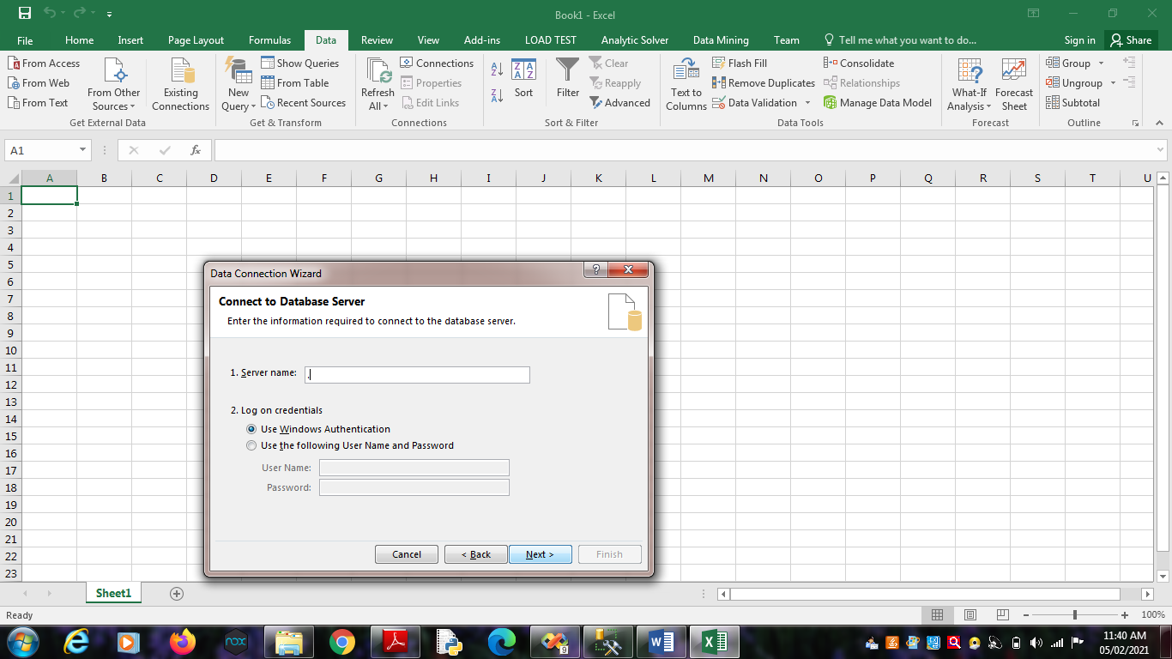

Click on Next.

Choose SQL Database -> “SalesProduct”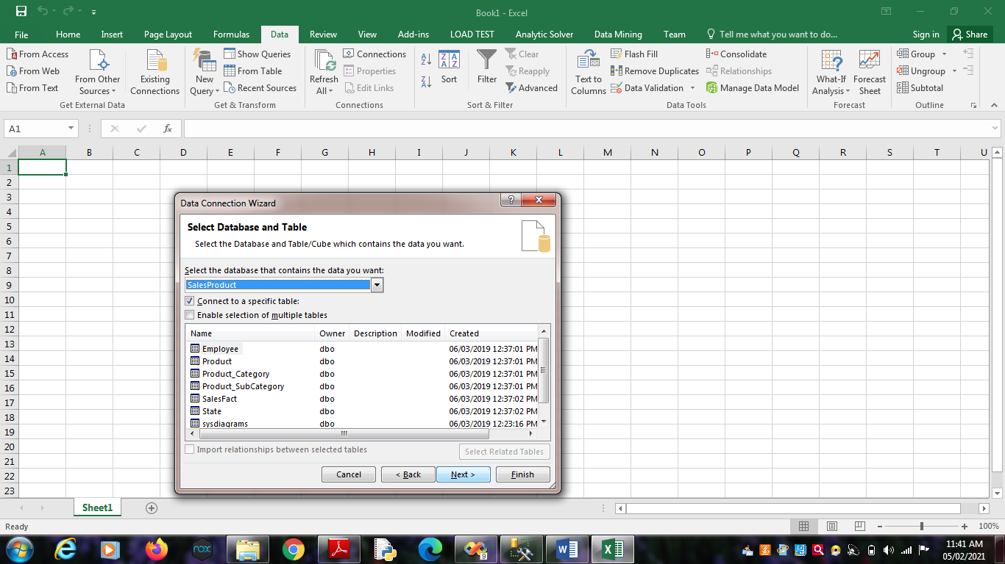

Click on Finish.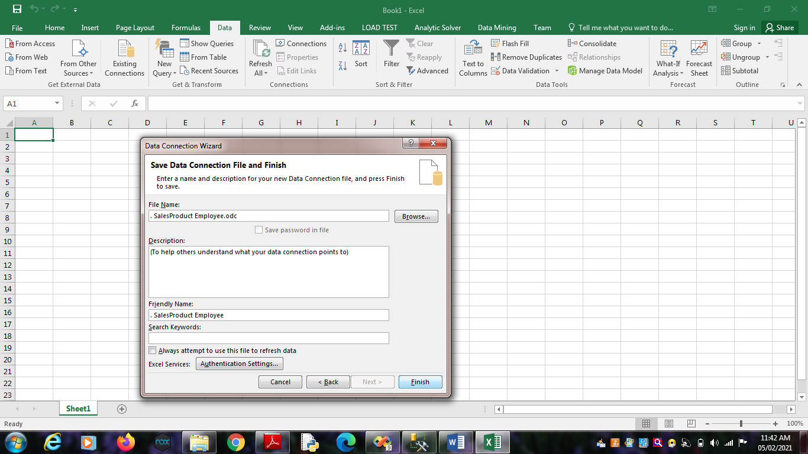

Click on OK.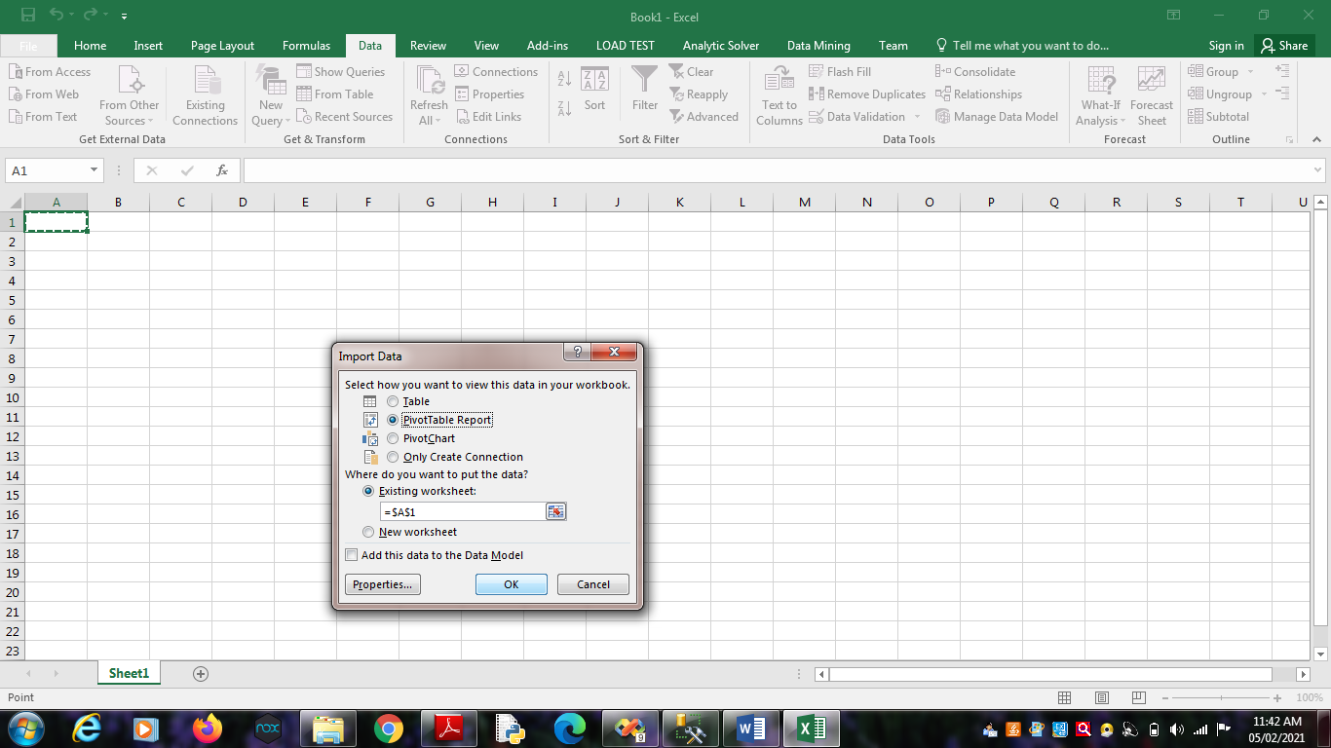

2.2. From Analysis Services -> Type Server name as “.”

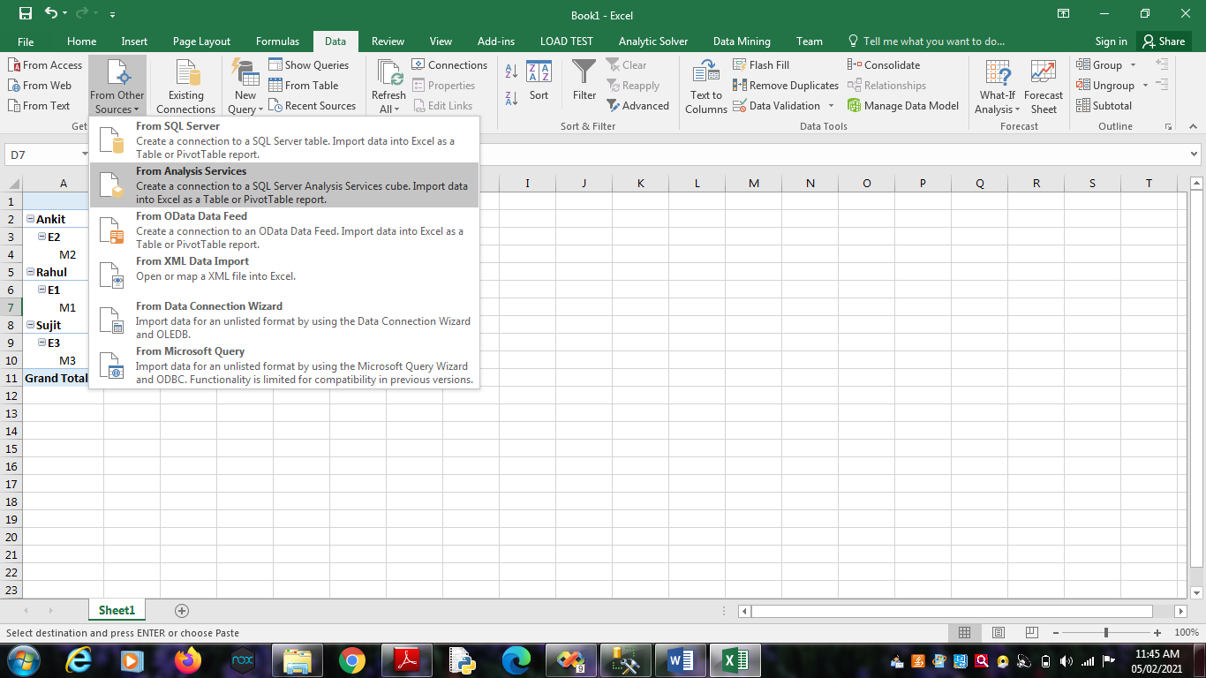

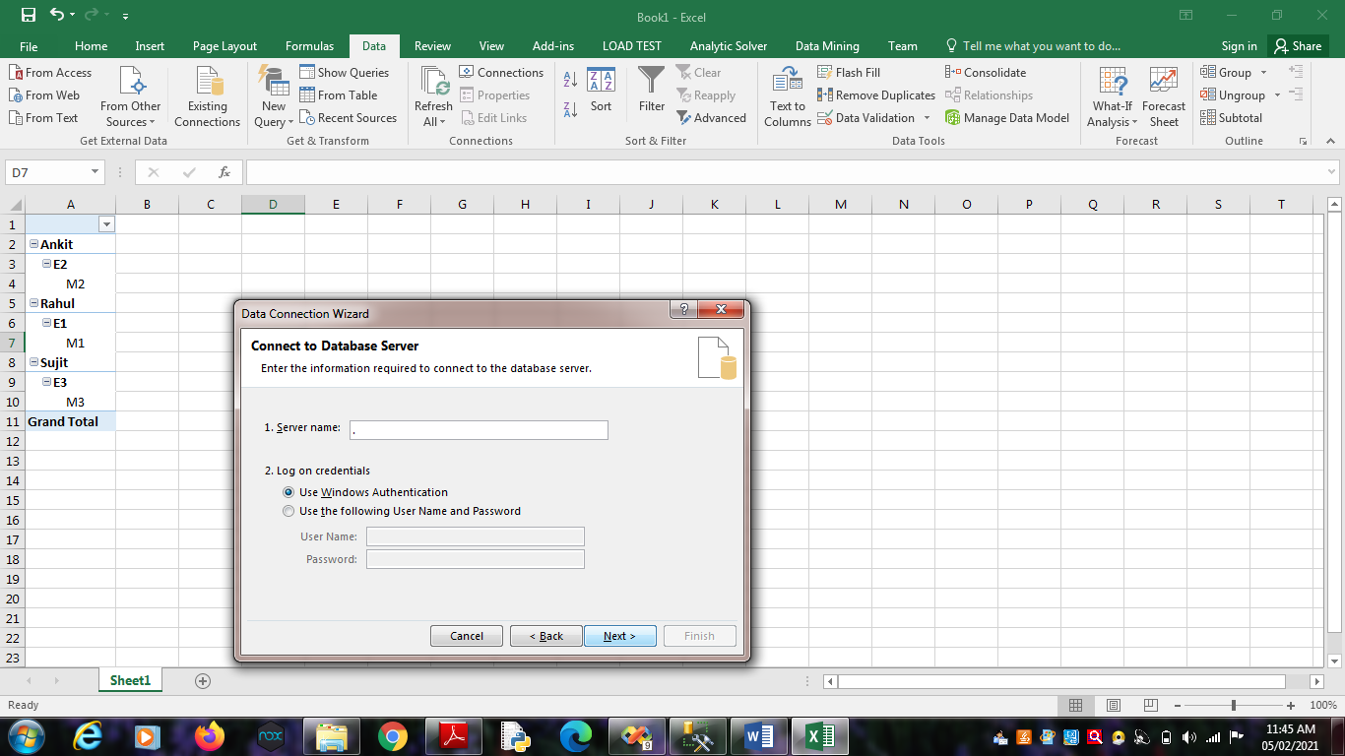

Click on Next.

Choose Analysis Database as “SalesProduct_BIPrj”. Click on

Next.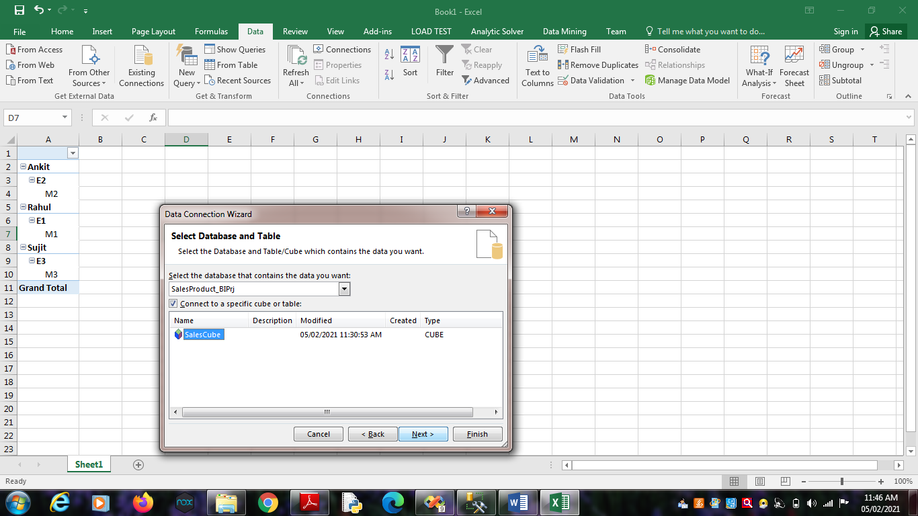

Click on OK.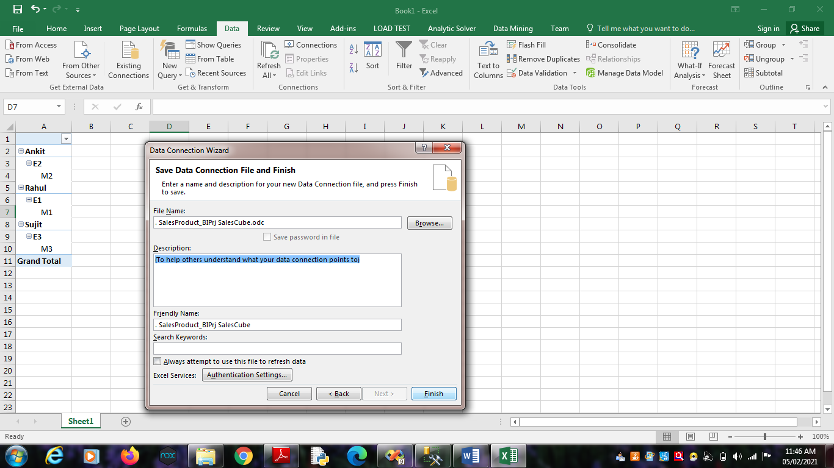

Click on Finish.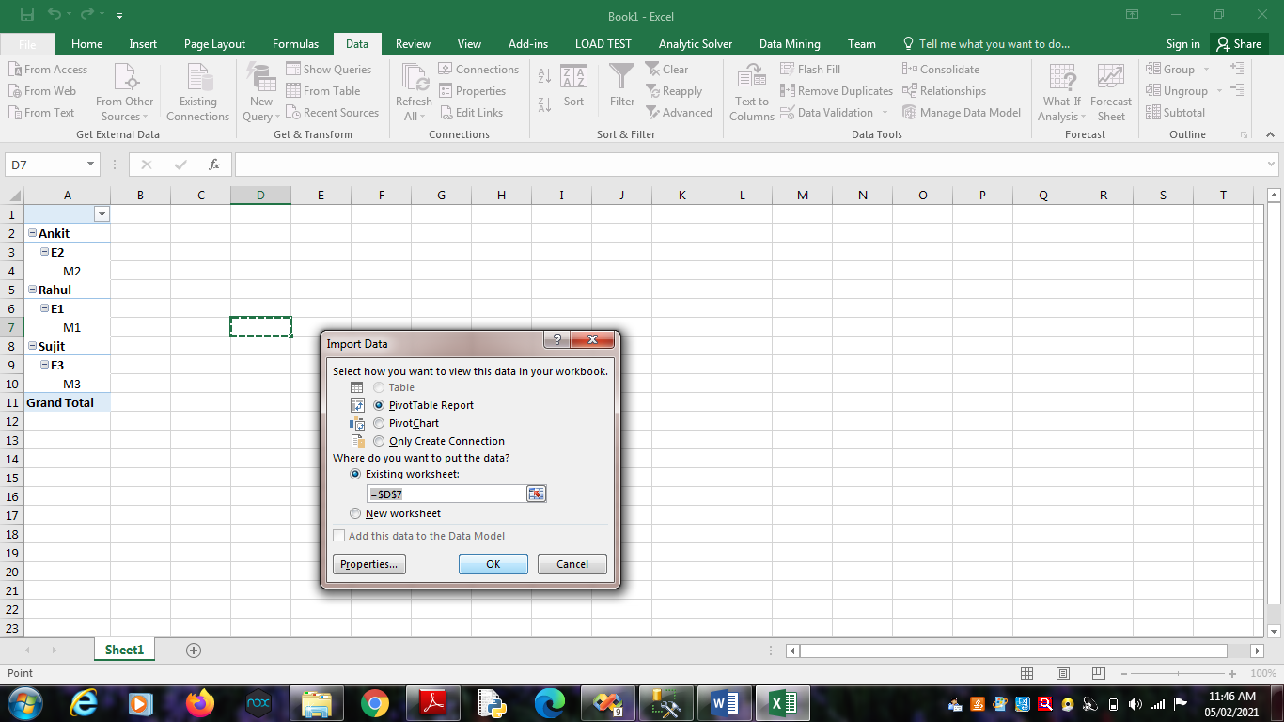

Click on OK.

3. Select State_ID, Product_ID,Employee_ID and Measures as

Sales_Dollars, Sales_Units and Sum Sales Dollars.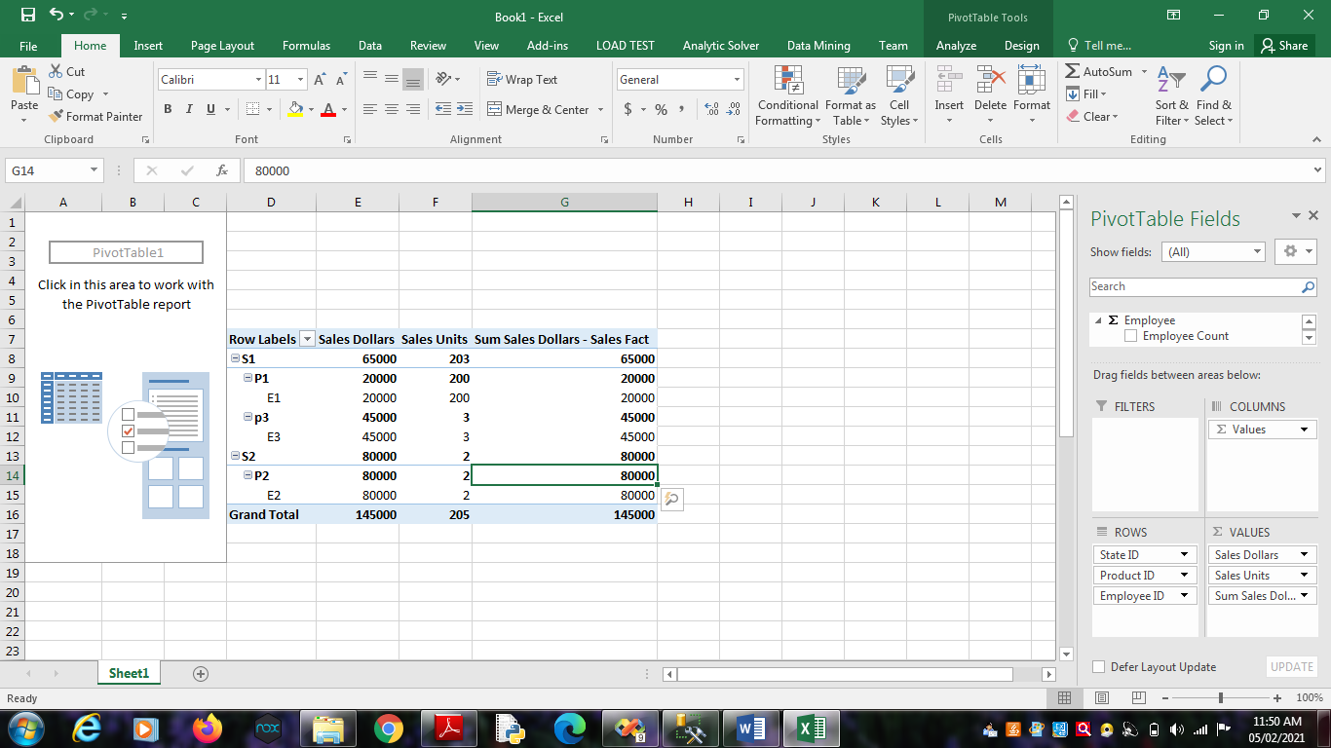

4. Select Result Area. Go to Insert Menu. Select Pie Chart option.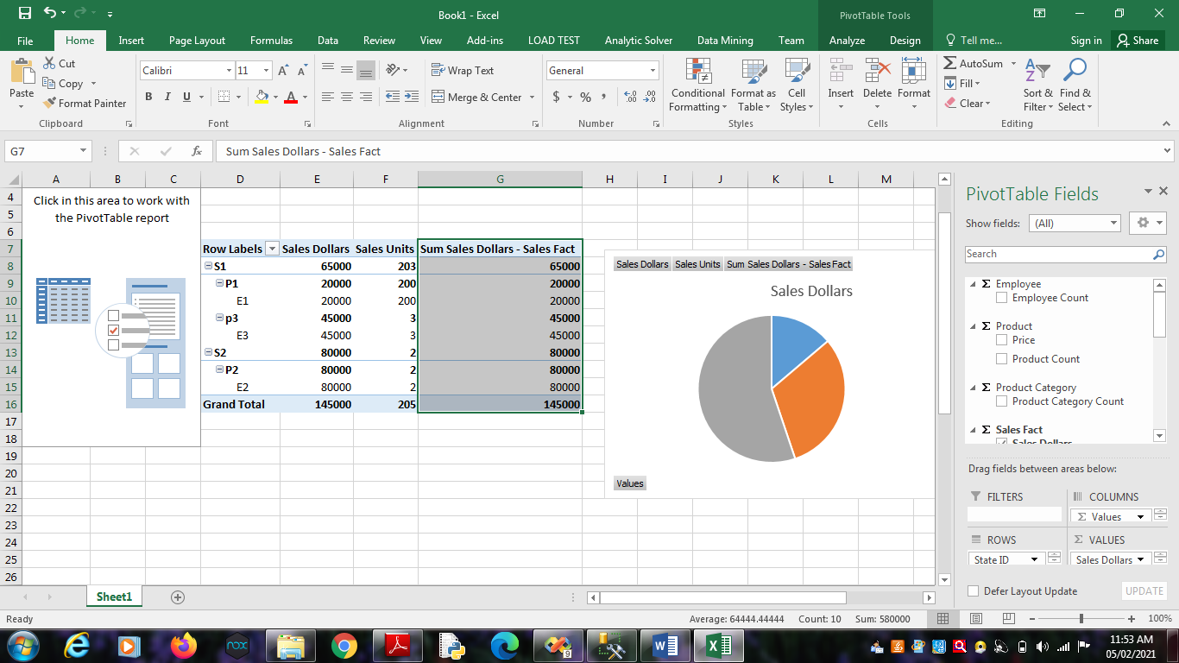

5. Select Result Area. Go to Insert Menu. Select Column option.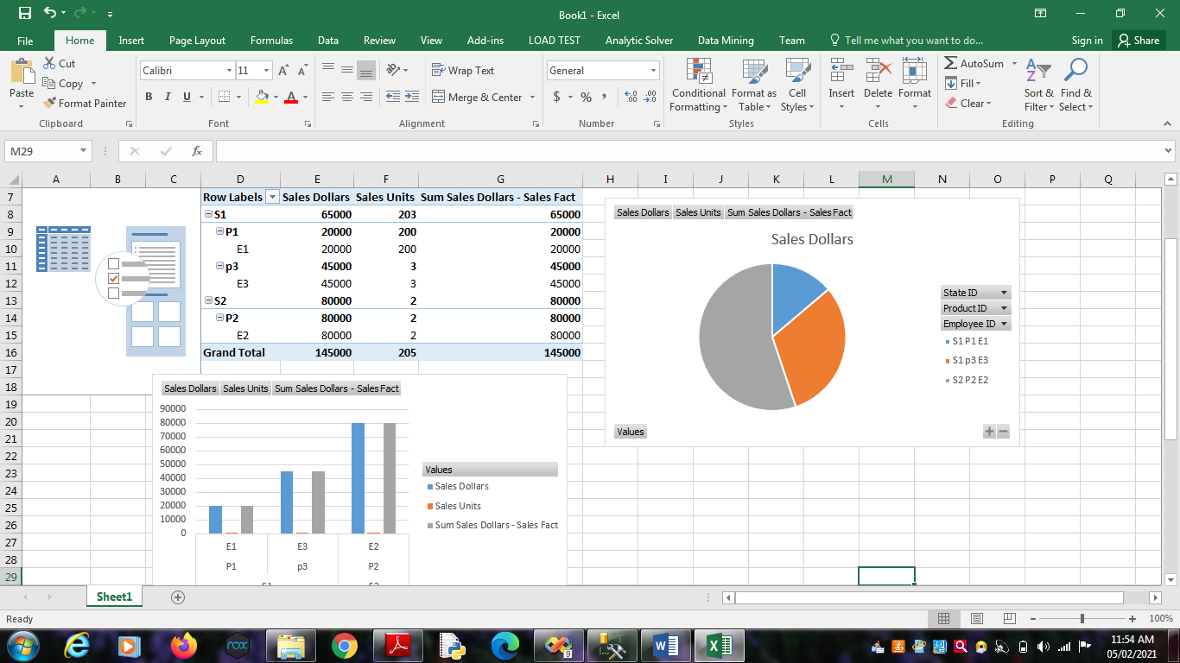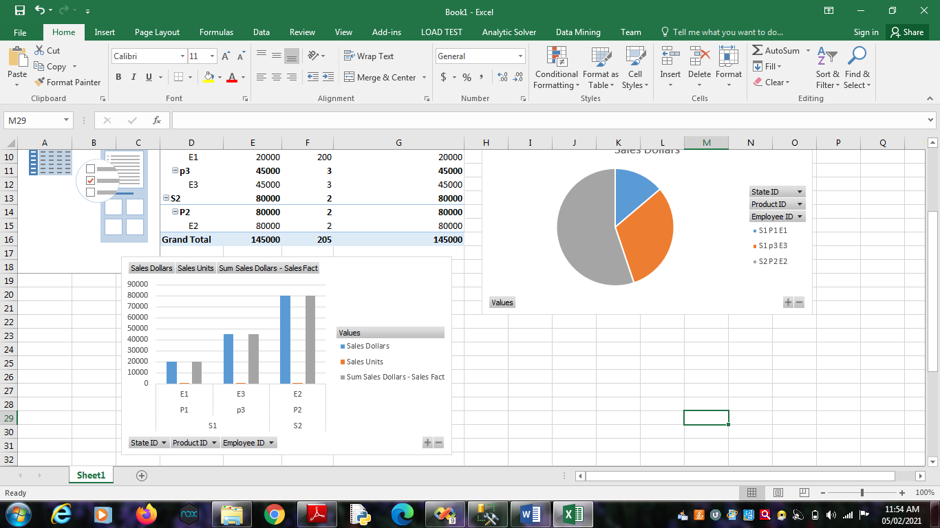

**Practical No 8**

**Aim**: Firing Queries on Tables.

**Solution:**

Open Application -> Microsoft SQL Server 2008 R2 -> SQL Server

Management Studio

1. Select Connect Tab -> Database Engine -> Select Server Name(local)



2. Expand ‘Database’ -> Expand ‘SalesProduct’ -> Expand Tables.

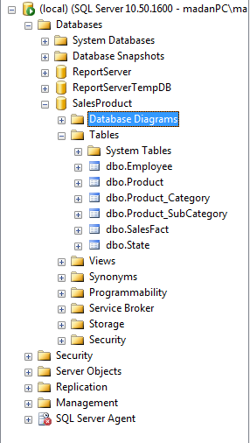

3. Fire following queries :

3.1. SELECT [Employee_ID],[Employee_Name] ,[Manager_ID]

FROM [SalesProduct].[dbo].[Employee]

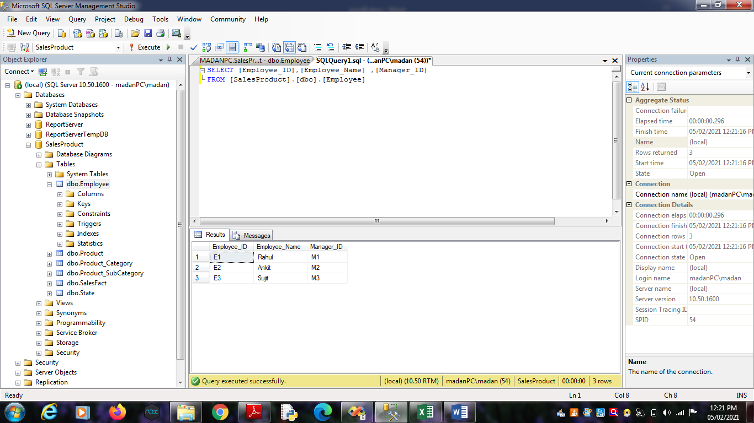

3.2 SELECT [Product_ID],[Brand_Name],[Price],[Product_Name]

,[SubCategory_ID] FROM [SalesProduct].[dbo].[Product]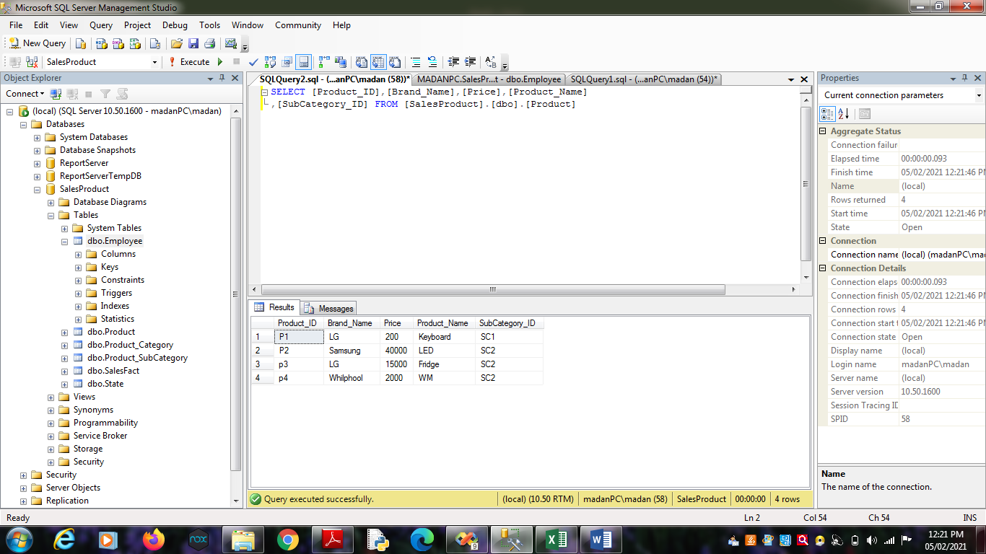

3.3. SELECT [State_ID],[Country],[Region],[State_Name]

FROM [SalesProduct].[dbo].[State]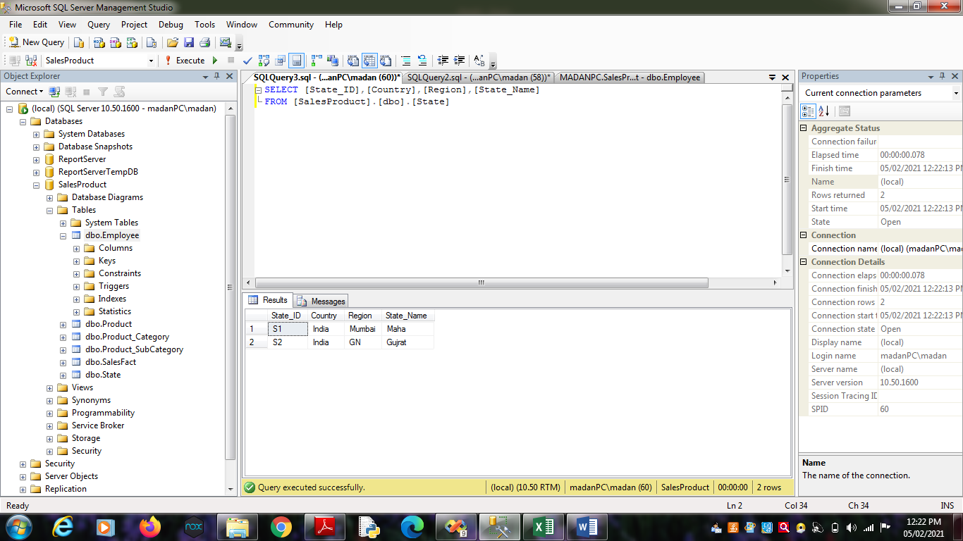

3.4. SELECT

[SubCategory_ID],[Category_Manager],[SubCategory],[Category_ID]

FROM [SalesProduct].[dbo].[Product_SubCategory]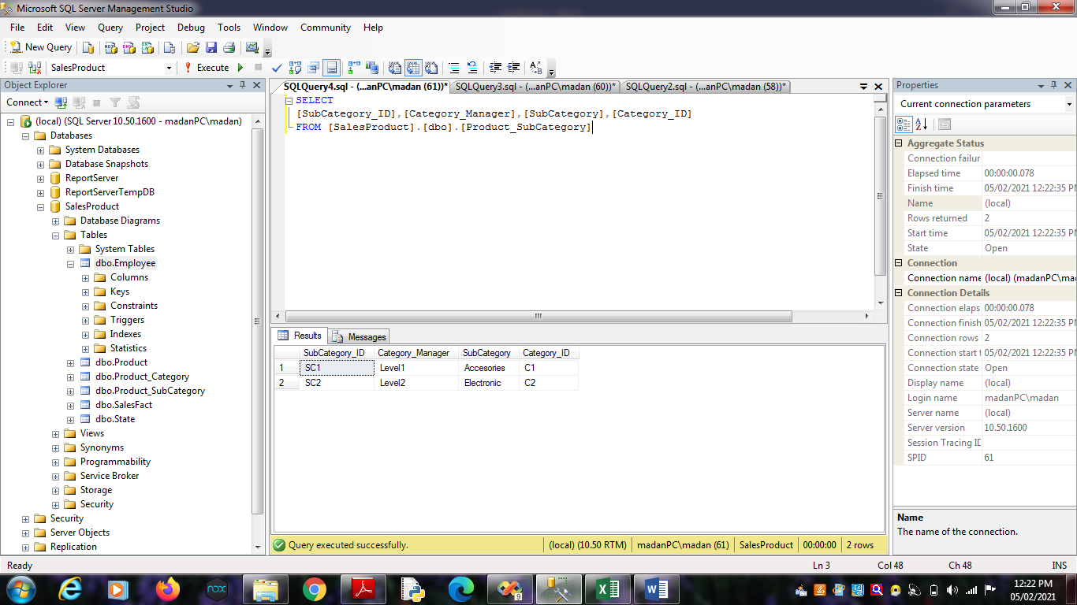

3.5. SELECT [Category_ID],[Category]

FROM [SalesProduct].[dbo].[Product_Category]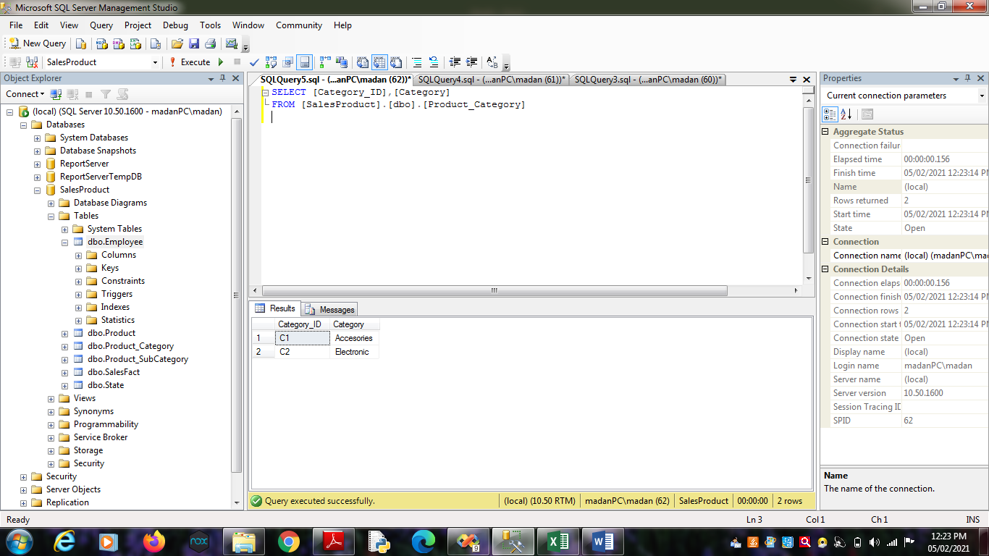

3.6. SELECT [Employee_ID],[Month],[Product_ID],[State_ID],[Sales_Dollars]

,[Sales_Units] FROM [SalesProduct].[dbo].[SalesFact]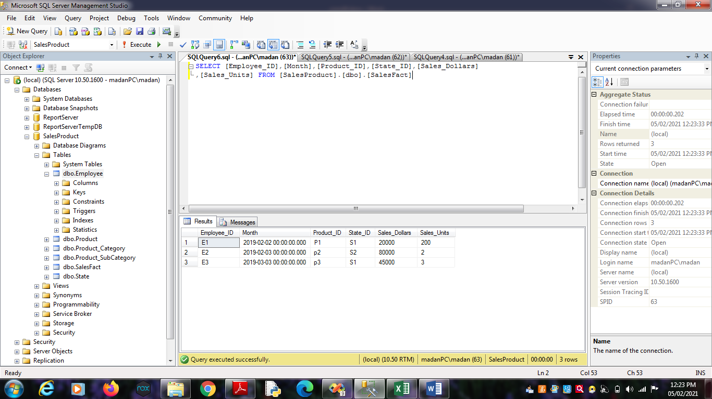

3.7. select [Employee_ID],[Sales_Dollars],[Sales_Units],

[SalesProduct].[dbo].[Product].[Product_ID],[Product_Name]

FROM [SalesProduct].[dbo].[SalesFact],[SalesProduct].[dbo].[Product]

where[SalesProduct].[dbo].[SalesFact].[Product_ID] =

[SalesProduct].[dbo].[Product].[Product_ID];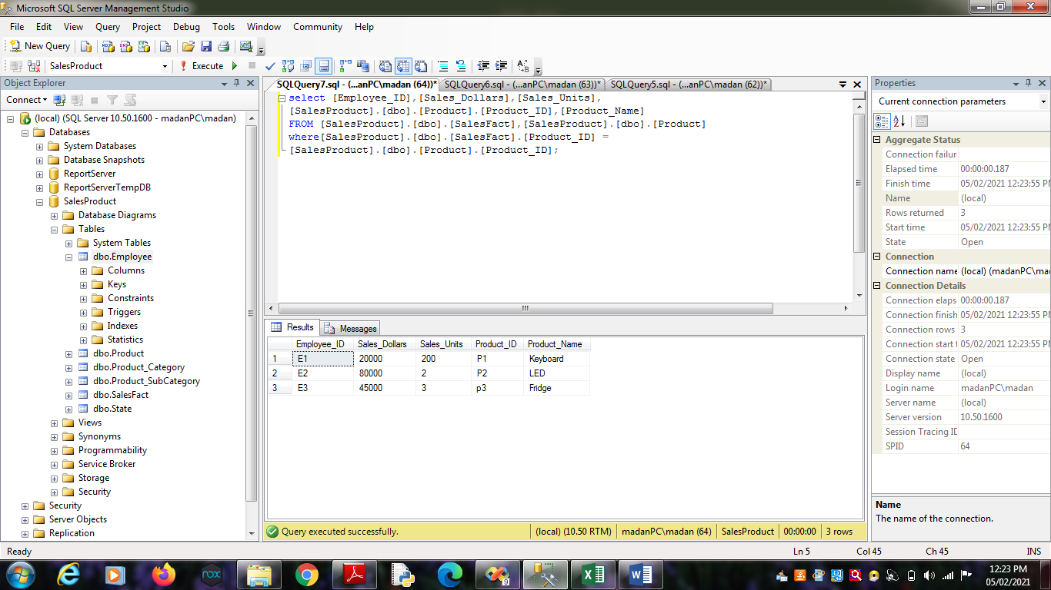

3.8. select [Employee_ID],[Sales_Dollars],[Sales_Units],

[SalesProduct].[dbo].[State].[State_ID],[State_Name]

FROM [SalesProduct].[dbo].[SalesFact],[SalesProduct].[dbo].[State]

where[SalesProduct].[dbo].[SalesFact].[State_ID] =

[SalesProduct].[dbo].[State].[State_ID];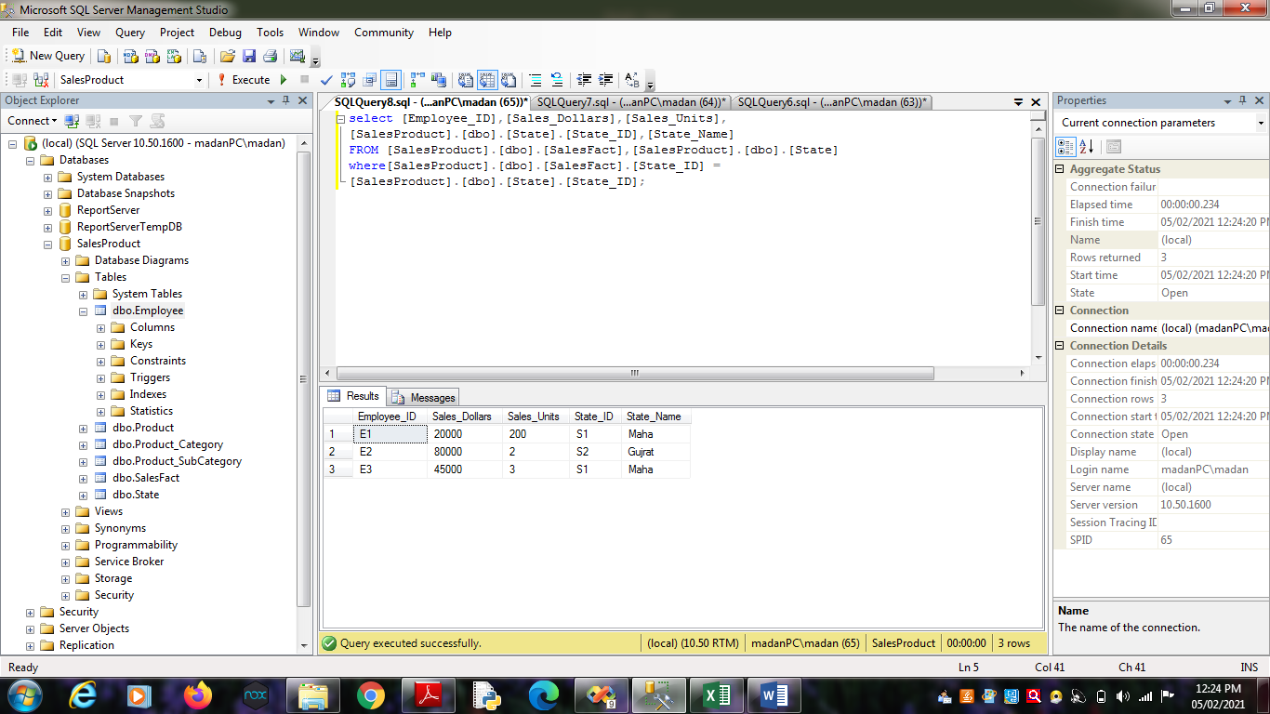

3.9. select [SalesProduct].[dbo].[Employee].[Employee_ID],[Employee_Name],

[Sales_Dollars],[Sales_Units]

FROM [SalesProduct].[dbo].[Employee] , [SalesProduct].[dbo].[SalesFact]

where [SalesProduct].[dbo].[Employee].[Employee_ID]=

[SalesProduct].[dbo].[SalesFact].[Employee_ID] ;